**Symposium Title**: Found in translation: How research finds new connections and methods

**Chairs:** Elizabeth Berry-Kravis and David Hessl

**Discussant**: Leonard Abbeduto

**Overview**: This symposium explores key issues in translating research in intellectual and developmental disabilities into accessible, practical, and impactful applications across diverse settings. The translation of key aspects of executive functioning to communication is examined through measures such as the NIH Toolbox. We analyze the challenges that adults with intellectual disability face when attempting to translate their skills to obtaining gainful employment, maintaining meaningful relationships, developing emotional and physical wellness routines, and making their own decisions that lead to independence. Finally, we examine the translation of clinical assessments to remote environments, increasing research trial accessibility for families. The symposium aims to foster dialogue around inclusive, responsive research practices that reflect the lived experiences of individuals with developmental disabilities and their families, featuring interdisciplinary perspectives from psychology, education, and allied fields.

**Paper 1 of 3**

**Paper Title**: Developmental associations between crystalized language and verbal reasoning among individuals with intellectual disability

**Authors**: Andrew Dakopolos, Aaron J Kaat, Richard Gershon, Jeanine Coleman, Elizabeth Berry-Kravis, and David Hessl

**Introduction**: The NIH Toolbox Cognition Battery (NIHTB-CB) represents an important and innovative technological approach to directly measure crystalized language skills, particularly in those with IDD (Shields et al., 2020, 2023). The Crystalized Cognition subtests of the NIHTB-CB (i.e., Picture Vocabulary and Oral Reading) have demonstrated excellent feasibility and reliability (Shields et al., 2020), as well as sensitivity to developmental change (Shields et al., 2023) in individuals with IDD, as well as sensitivity to treatment as an outcome in a clinical trial of adults with FXS, and is a promising method to measure cognitive outcomes in individuals with IDD (Berry Kravis et al., 2021). Despite these advances, the present study seeks to demonstrate the clinical relevance of the NIHTB-CB as a primary outcome measure – specifically whether improvements in crystalized skills translate to improvements in individuals’ verbal reasoning abilities on gold-standard measures of verbal reasoning (i.e., the Verbal Knowledge and Verbal Fluid Reasoning subtests of the Stanford Binet 5th Ed.) among children and young adults with IDD.

**Method**: Participants were between 6 and 26 years at visit 1 (n = 264), and had a diagnosis of ID, or suspected ID. In order to examine the association of developmental change between crystalized cognition and verbal reasoning, two bivariate latent change score (BLCS) models were fit (Kievit et al., 2018). The model contained latent scores for Crystalized Cognition, derived from uncorrected standard scores from the domain’s subtests (Oral Reading and Picture Vocabulary), and the raw score for Verbal Knowledge (model 1) and Verbal Fluid Reasoning (Model 2) at Visit 1 and Visit 2.  Latent change scores for Crystalized Cognition (ΔCC), Verbal Knowledge (ΔVK), and Verbal Fluid Reasoning (ΔVFR) were included to model change from Visit 1 to Visit 2. Time between visits (m = 2.45 years, range = 1.27 to 5.56 years) and participant age (m = 15.52, sd = 5.17) were used as covariates at the manifest level. Model fit was evaluated using the Hu & Bentler (1999) thresholds for good fit (i.e., SRMR≤0.08, CFI≥0.95, and RMSEA<0.06).

**Results**: Results indicated overall good model fit (Model 1: SRMR = 0.70, CFI = 0.984, RMSEA = 0.064; Model 2: SRMR = 0.60, CFI = 0.988, RMSEA = 0.058). Models showed a positive relationship between ΔCC and ΔVK (β = 7.92(3.03), p = .009) and ΔCC and ΔVFR (β = 4.91(2.07), p = .018) indicating that changes in crystalized cognition relate to change in verbal reasoning skills over time in our sample. In addition, CC at Visit 1 positively predicted ΔVK (β = 0.34(0.09), p < .001) and ΔVFR (β = 0.21(0.05), p < .001), demonstrating that higher crystalized cognition scores at Visit 1 predicted greater change in verbal reasoning.

**Discussion**: The present study found that developmental growth among directly measured language constructs was positively related over a 2-year period for individuals with IDD. The NIHTB-CB Crystalized Composite is sensitive to developmental change, and is associated with developmental changes in another gold-standard assessment of verbal reasoning across two verbal reasoning domains, indicating that the NIHTB-CB may be a strong candidate to be used an outcome linked to clinically relevant functional language change in individuals with IDD. In addition, individuals with IDD who have higher crystalized language abilities at baseline could be strong candidates for intervention, because in our sample, they demonstrated greater gains in verbal reasoning skills over a two-year developmental period.

**References**

Berry-Kravis, E. M., Harnett, M. D., Reines, S. A., Reese, M. A., Ethridge, L. E., Outterson, A. H., Michalak, C., Furman, J., & Gurney, M. E. (2021). Inhibition of phosphodiesterase-4D in adults with fragile X syndrome: a randomized, placebo-controlled, phase 2 clinical trial. Nature Medicine, 27(5), 862–870. https://doi.org/10.1038/s41591-021-01321-w

Kievit, R. A., Brandmaier, A. M., Ziegler, G., van Harmelen, A. L., de Mooij, S. M. M., Moutoussis, M., Goodyer, I. M., Bullmore, E., Jones, P. B., Fonagy, P., Lindenberger, U., & Dolan, R. J. (2018). Developmental cognitive neuroscience using latent change score models: A tutorial and applications. In Developmental Cognitive Neuroscience (Vol. 33, pp. 99–117). Elsevier Ltd. https://doi.org/10.1016/j.dcn.2017.11.007

Shields, R. H., Kaat, A. J., McKenzie, F. J., Drayton, A., Sansone, S. M., Coleman, J., Michalak, C., Riley, K., Berry-Kravis, E., Gershon, R. C., Widaman, K. F., Hessl, D., & Hessl, D. (2020). Validation of the NIH Toolbox Cognitive Battery in intellectual disability. Neurology, 94(12), e1229–e1240. https://doi.org/10.1212/WNL.0000000000009131

Shields, R. H., Kaat, A., Sansone, S. M., Michalak, C., Coleman, J., Thompson, T., McKenzie, F. J., Dakopolos, A., Riley, K., & Berry-Kravis, E. (2023). Sensitivity of the NIH Toolbox to Detect Cognitive Change in Individuals With Intellectual and Developmental Disability. Neurology, 100(8), e778–e789.

Widaman, K. F. (2006). Best practices in quantitative methods for developmentalists: III. Missing data: What to do with or without them. Monographs of the Society for Research in Child Development.

**Paper 2 of 3**

**Paper Title**: Translating technology into increased accessibility with remote evaluations

**Authors**: Anne Hoffmann, Leonard Abbeduto, Angela John Thurman, and Elizabeth Berry-Kravis

**Introduction**: Research in rare disorders has long recognized that access to clinical sites is a strong determiner of participation in research (Kempf, Goldsmith, & Temple, 2017). This difficulty extends beyond the distance families might need to travel, there are also the logistical challenges including missed work and/or school and increased stress for child and caregiver. This results in less participation from key populations, especially families from under-resourced communities. One suggested facilitator for increasing access is to allow some visits to be done via telehealth, thus sparing families the burden of traveling to the clinical site for all visits (Inan et al., 2020). This study examines data from the FXLearn trial, comparing results of the Weighted Communication Scale (a communication sample coding schema) delivered in-person and remotely. This measure assesses wide-ranging communication skills and has been validated in young children with FXS (Thurman, Alvarez, & Nguyen, 2022). It samples communication in two contexts, a structured table-based activity and an unstructured floor-based activity.

**Method**:

This is a retrospective study from data collected during the FXLearn trial. Participants were children with fragile X syndrome (FXS) ranging in age from 2;00 to 6;11. Participation was over a period of 18 months, with WCS administrations in months 1,3,5,7,8,9,11,12,14, and 15. There are a total of 831 WCS scores, of which 81 were completed remotely. Wel assessed the feasibility of these remote evaluations by 1) calculating the percentage that were considered “scorable” and 2) noting the number of deviations from standard protocol and comparing these to what occurred with the in-clinic evaluations. We also calculated correlations between the WCS and other measures of communication such as the Macarthur-Bates Communication Development Inventories-Second Edition (CDIs; Fenson et al., 2006) and the expressive language subscale of the Vineland Adaptive Behavior Scales-Third Edition (Vineland-3; Sparrow, Cicchetti, & Saulnier, 2016).

**Results**:

For WCS administrations, 97.57% (812/831)were able to completed in-clinic and 100% (81/81) remotely. Of the in-clinic administrations, 6% (47/831) had at least one section that was not scorable, typically because of child behavior or camera placement. The remote WCSs had one administration that was not-scorable because of excessive prompting by the parent.

Initial correlations were calculated for a subset of participants using Spearman rank order coefficients. For the in-clinic evaluations, there were significant correlations between the expressive language scale of the Vineland-3 and both the structured portion of the WCS (*ρ* = .566, *p* < .0001) and the unstructured portion (*ρ* = .625, *p* < .0001). Similarly strong correlations were seen with the in-clinic administrations for both the unstructured (*ρ* = .549, *p* < .0001) and structured (*ρ* = .659, *p* < .0001). Analysis is on-going with final results expected shortly.

**Discussion**:

These results provide initial validation for the remote administration of the WCS. The data analysis demonstrates both feasibility and efficacy, having high rates of completion and similar correlations to another widely used language measure. This supports the use of remote communication samples, thus increasing families’ access to clinical trials while decreasing family burden.

**References**

Fenson, L., Marchman, V. A., Thal, D. J., Dale, P. S., Reznick, J. S., & Bates, E. (2006). MacArthur-Bates

Communicative Development Inventories, Second Edition (CDIs) [Database record]. APA PsycTests.

Inan, O. T., Tenaerts, P., Prindiville, S. A., Reynolds, H. R., Dizon, D. S., Cooper-Arnold, K., ... & Califf, R. M. (2020).

Digitizing clinical trials. *NPJ Digital Medicine*, *3*(1), 101.

Kempf, L., Goldsmith, J. C., & Temple, R. (2018). Challenges of developing and conducting clinical trials in rare

disorders. *American Journal of Medical Genetics Part A*, *176*(4), 773-783.

Sparrow, S. S., Cicchetti, D., & Saulnier, C. (2016). Vineland Adaptive Behavior Scales (Third Edition ed.). San

Antonio, TX: Pearson

Thurman, A., Hoyos Alvarez, C., & Nguyen, V. (2022). Using weighted communication scoring procedures in

naturalistic play samples: Preliminary validation in preschool‐aged boys with autism or fragile X

syndrome. *Autism Research*, *15*(9), 1755-1767.

**Paper 3 of 3**

**Paper Title**: How communication skills translate into the academic setting for college students with intellectual disabilities

**Authors**: Jeanine Coleman, Morgan McNeill, Lauren Gray, and Grace Maddox

**Introduction**: Students with intellectual disabilities in an inclusive higher education program participated in a research study to measure their language and communication skills and how they translate into the academic setting. The students in this inclusive higher education program have a diagnosis of intellectual disability but the etiology varies from Down syndrome, autism spectrum disorder, and other unknown causes of intellectual disability. Due to the students’ disability, their communication skills are significantly delayed compared to neurotypical college students (Klefbeck, 2021). This makes their inclusion in college courses challenging, but with the support of the inclusive higher education program staff and peer mentors, the students are thriving in this setting (Kelly & Westling, 2019). Communication skills are weaved through all the pillars of the inclusive higher education program, such as academics, physical and emotional wellness, social engagement, career development, and independent living. These skills were measured by the subtest of oral reading and picture vocabulary in the NIH Cognitive Toolbox battery and compared to the evaluations of the student competencies as completed by staff, faculty, internship supervisors, and parents.

**Method**: Students were administered the NIH Cognitive Toolbox in spring 2024. Parents and staff completed the evaluation of the student competencies with a rating of 0-4 based on the indicators of the competencies. For this study, to focus on communication, we have analyzed the data from the Oral Reading and Picture Vocabulary of the NIH Cognitive Toolbox and the academic competencies and indicators from the student evaluation.

Participants: 18 students with intellectual disabilities in an inclusive higher education program.

Gender: 10 males; 8 females

Age: Range: 19-36 years; Mean: 23 years

Disability category: Down syndrome (n = 10), Williams syndrome (n =1), autism spectrum disorder (n = 5), unknown causes of intellectual disability (n = 2)

Missing data: Subtests on the NIH Cognitive Toolbox: n=13; Competencies: n=16

**Results**: This study examined communication skills of college students with intellectual disabilities and how those skills are translated into the academic setting. Analysis included descriptive statistics of two subtests of the NIH Cognitive Toolbox that focused on communication and language and student competencies related to the academic pillar in the inclusive higher education program.

The NIH Cognitive Toolbox subtests, Oral Reading and Picture Vocabulary are the primary measures for communication and language skills and delivered through an iPad application. Of the 18 students, 13 completed both subtests. During the Oral Reading subtest, students are presented with a letter or word and asked to read that word even if they do not know the meaning. The assessment administrator scores whether the student read the word correctly using a wireless keyboard (0 for incorrect, 1 for correct). In the Picture Vocabulary subtest, students are presented with four pictures and then asked to identify the word spoken. The app scores the reversals and ceiling automatically. The normed scores have a mean of 100 and standard deviation of 15.

Oral Reading: Students scored a range of 39 to 103 with a mean of 56.3 and standard deviation of 17.6. This indicates that students have a substantial variability in reading ability, but with a mean of 56, most are significantly below the average mean compared to same-age, college peers.

Picture Vocabulary: Students scored a range of 39-94 with a mean of 61.3 and standard deviation of 19.4. Again, there is a wide variability of scores, but with the mean of 61, it is outside the normal range compared to same-age, college peers.

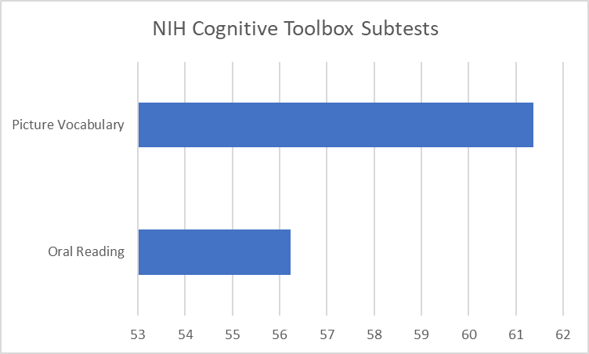

Student Competencies Rating Scale: Staff and parents completed surveys on the students’ academic and social competencies. For this study we focused on academic competencies such as reading to acquire skills and knowledge, writing to express knowledge, and participating in class discussions. Ratings were based on a scale from 0-4, with higher ratings indicating more competencies. The ratings from the staff (n=18) are primarily in the “developing” range indicating that most the students have basic reading skills and need additional support to use those skills in a college setting. Parent ratings (n-11) are slightly lower, primarily in the “needs improvement” range.

* 0—unable to rate
* 1—Needs improvement
* 2—Developing
* 3—Proficient
* 4—Advanced

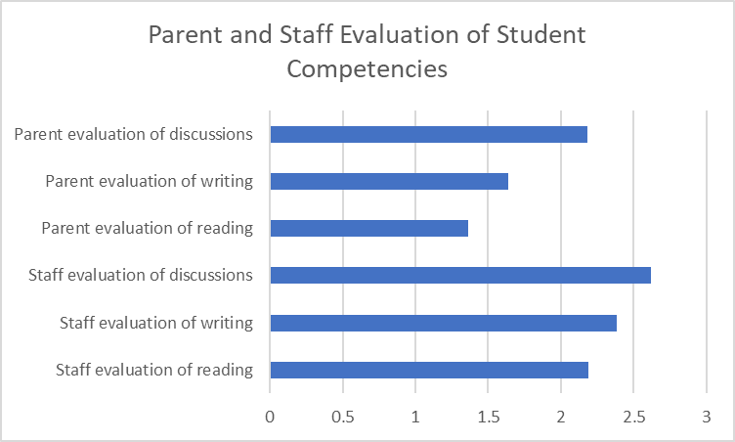

**Discussion**: In this study, we analyzed the initial findings of communication and language skills for college students with intellectual disabilities and how they translate into an inclusive higher education setting. There is clear evidence of the unique challenges of this group when it comes to participating in the academic setting. By looking at the foundational cognitive skills, primarily language and communication, we can individualize our interventions to support the students in their abilities to comprehend the content, and actively participate in this academic and social setting. Reading and vocabulary are important parts of the academic language all students need to succeed in college. For students with intellectual disabilities, specific and targeted interventions are necessary so that they can fully participate in an environment in which they were historically excluded.

The discrepancy between staff and parent ratings of student competencies may be because parents are not aware of the structured supports that students receive in and outside the classroom, such as tiered tutoring, modified assignments, chunking of content, and simplified language. Furthermore, parents may have lower expectations of their child in this setting, simply because they do not see this in this setting on a regular basis.

Both staff and parents rated the students higher on participating in class discussions rather than reading and writing competencies. This may be because many of our students have good oral communication skills and want to social and included in the college experience. Anecdotal evidence demonstrates that our students listen and participate in class discussions more than the neurotypical students. With the right engagement, they participate in meaningful discussions and use the language of the course to demonstrate their understanding of course content and concepts.

**References**

Kelley, K.R. & Westling, D.L. (2019). Teaching, including, and supporting college students with intellectual disabilities. New York: Routledge.

Klefbeck, K. (2021). Educational Approaches to Improve Communication Skills of Learners with Autism Spectrum Disorder and Comorbid Intellectual Disability: An Integrative Systematic Review. Scandinavian Journal of Educational Research, 67(1), 51–68. https://doi.org/10.1080/00313831.2021.1983862