Symposium Title: Examining Moderators and Maintenance Effects of a Transition Intervention for Autistic Adolescents and Young Adults
Chair: Matthew J. Smith
Discussant: Mary Baker-Ericzen
Overview: Autistic adults’ employment rates remain extremely low, posing a clinically significant problem given the benefits of employment for well-being, independence and life satisfaction in all adults. We present integrative cross-disciplinary strategies to improve employment outcomes in autistic individuals. Dr. Brianne Tomaszewski will present findings from a clinical trial of the TEACCH Autism Program, School Transition to Employment and Postsecondary Education Program (T-STEP), a community college-based transition program for autistic students that includes self-determination and executive function training, counseling and an internship. Dr. Matthew Smith will then discuss a Hybrid Type I trial of the effectiveness, feasibility, and acceptability of a virtual workplace communication training platform (WorkChat) developed with members of the autistic community and implemented in 4 post-secondary pre-employment transition services. Dr. Ben Schwartzman will discuss his study of a parent mentorship program to assist parents in connecting their adult autistic and/or intellectual disabled family members with paid employment. Finally, Dr. Marjorie Solomon will present results of a Hybrid Type 1 effectiveness trial examining employment outcomes, and feasibility and acceptability of the highly validated Individualized Placement and Support (IPS) model –which has been used extensively and successfully in the severe mental illness field –implemented in autistic adults in the community.
Paper 1 of 4
Paper Title: Examining Moderators and Maintenance Effects of a Transition Intervention for Autistic Adolescents and Young Adults.
Authors: Brianne Tomaszewski, Elena Lamarche3, Michal Cook3, Claire Klein³, Tabetha Marsh³, Bridgette Kiernan³, Glenna Osborne³, & Laura G. Klinger³
Introduction: The TEACCH School Transition to Employment and Postsecondary Education (T-STEP) is a 12-week community college program that supports transition-aged autistic youth in pursuing their individualized goals for a successful adult life. The T-STEP has three components. For each week: (1) two 1.5-hour classes focused on self-determination, executive function, professional social skills, and coping skills; (2) 1-hour internship; and (3) 1-hour counseling sessions focused on self-advocacy, career counseling, and disability services. In a comparative efficacy trial, students received either all three components (Comprehensive T-STEP) or the weekly counseling component (Counseling). Students in the Comprehensive T-STEP reported more significant gains in self-determination and coping skills compared to students in the Counseling group. Parents reported gains in both groups for self-determination and executive function (masked authors et al., 2024). The objectives of the current study were to (1) examine the maintenance effects of the comprehensive T-STEP and Counseling programs at a 3-month follow-up timepoint and (2) examine moderators of the comprehensive T-STEP and Counseling groups to identify characteristics of adolescents and young adults (e.g., IQ, autism characteristics, anxiety) who benefited most from the two programs.
Method: 110 autistic adolescents and young adults ages 16-21 (M=18.21, SD=1.32) with IQ ≥ 80 (M=107.72, SD=15.32) were randomly assigned to complete the 12-week (Comprehensive T-STEP (N=58) or Counseling (N=52). 68.8% of the participants were male, 82.0% were White, 15.0% were Black, 2.0% were Asian, and 4.8% were Latine. During the pre-test, an IQ test was performed (WASI-II), and caregivers completed a measure of autism characteristics (SRS-2). During the pre-test, post-test, and 3-month follow-up, autistic students completed measures of self-determination (AIR-SDS), coping skills (Coping Self-Efficacy Scale), anxiety (State-Trait Anxiety), and depression (CESD-R). Caregivers completed measures of self-determination and executive function (BRIEF). Linear mixed models examined moderators of IQ, autism characteristics, and anxiety on the outcomes for the Comprehensive T-STEP and Counseling groups and outcomes over the three- time points.
Results: Effects were maintained at follow-up for self-determination and coping skills. Autism characteristics significantly moderated treatment effects between Comprehensive T-STEP and Counseling on student-reported depression, F(2,8) = 3.22, p = .04 and parent-reported executive function, F(5,110) = 2.37, p = .04. Autistic students with average (T-Score=68) and high (T- Score = 77) SRS-2 scores in the Comprehensive T-STEP reported decreases in depression from pre-test to follow-up. Individuals in the Comprehensive T-STEP maintained their gains in executive function skills from the pre-test to follow-up across low, average, and SRS-2 scores. Individuals in the Counseling group maintained their gains if their SRS-2 scores were low or average, but not if they were high (see Figure 1).
Discussion: Students receiving the Comprehensive T-STEP maintained their gains in self-determination and coping skills three months after completing the program. Autism characteristics were a significant moderator for depression and executive function. This analysis suggests that the Comprehensive T-STEP may work best for students with more autism characteristics, and students in the Counseling group may work best for students with less autism characteristics. Findings highlight the need for individualized approaches to interventions for autistic students.
Reference: masked author/publication
Figure 1. Moderation of Autism Characteristics on Student-Reported Depression and Parent-Reported Executive Function Between Comprehensive T-STEP and Counseling Programs over Pre-Test, Post-Test, and a 3-month Follow-Up
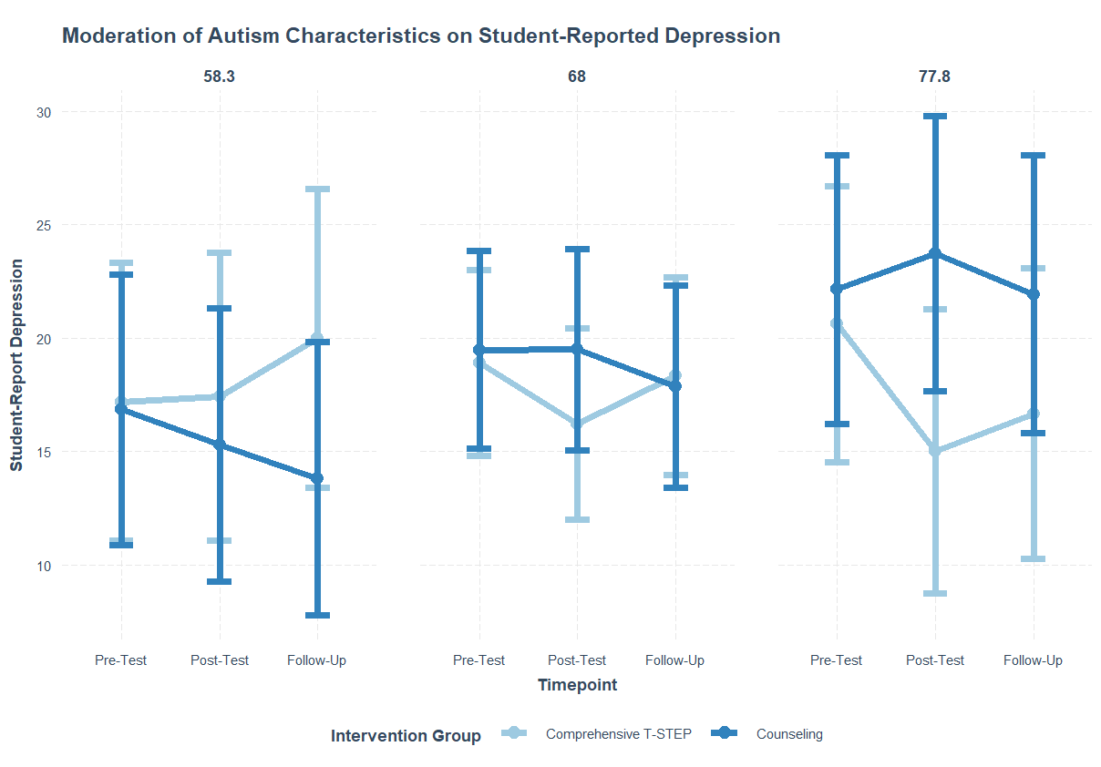

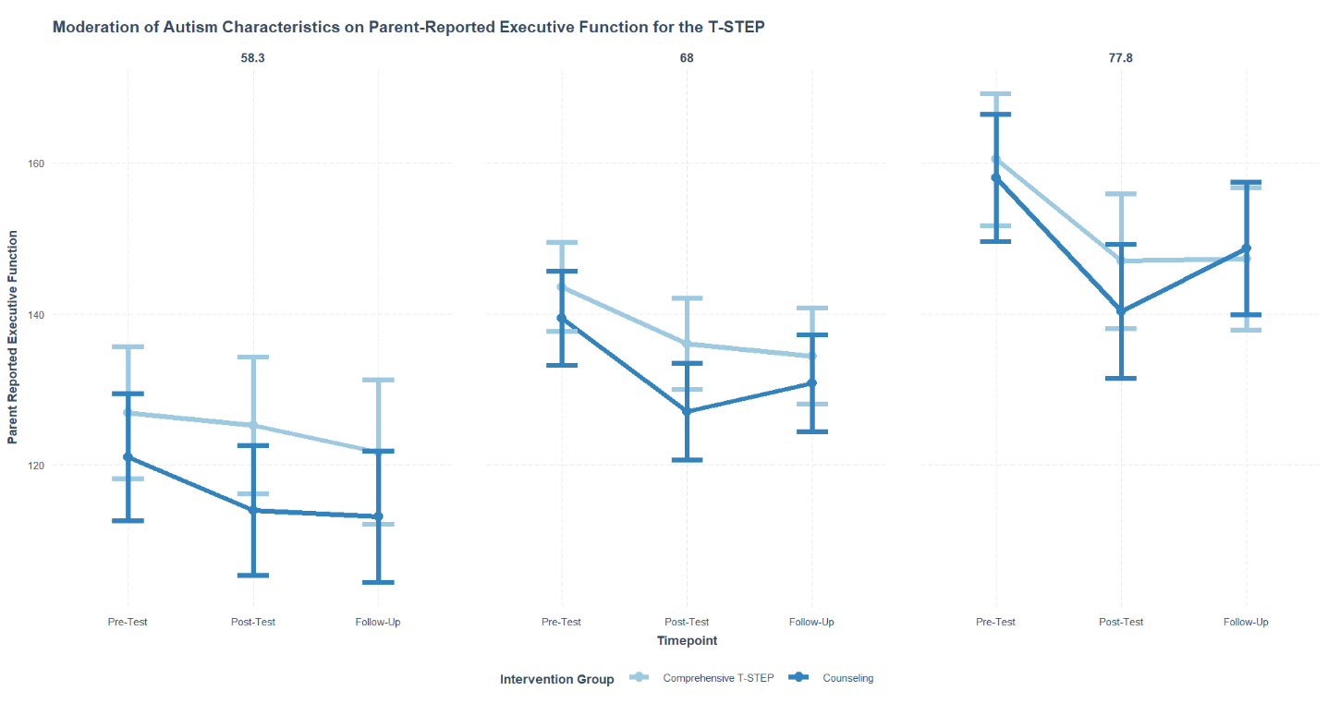

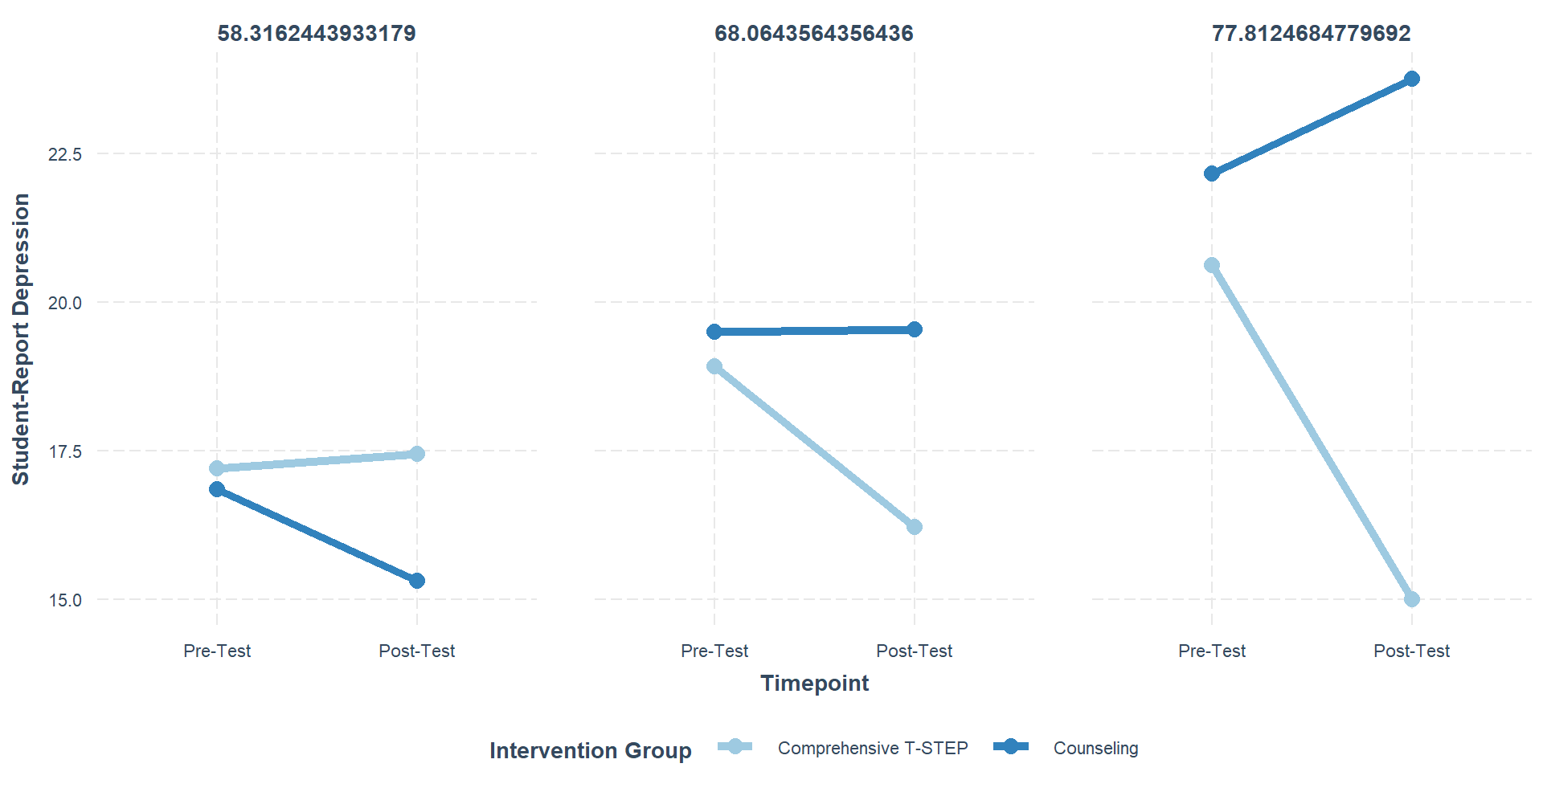
Paper 2 of 4
Paper Title: Initial Findings from a Hybrid Type I RCT of WorkChat: A Virtual Workday for Autistic Transition-Age Youth Delivered in Pre-Employment Transition Services.
Authors: Matthew J. Smith1, Kari Sherwood1, Connie Sung, Ed-Dee William, Brittany Ross4, Apara Sharma4, Cheryl Brown, David Telfer, Justine Bond, Sen Toda, David Kearon, Shelby Morrow, Temple Lovelace, Sarah Dababnah, Shanna K. Kattari4, Sandra Magaña, Tikia Watkins, Caleb Liggett8, Edwina Riddle, Justin D. Smith, Kara Hume, Tamara Dawkins2⁰, Mary Baker-Ericzen, Shaun M. Eack, Jane K. Burke-Miller, Dale Olsen, Jeff Elkins2⁴, Laura Humm2⁴, Chris Steacy2⁴.
Introduction: Nearly 50,000 autistic youth transition from high school to adult life each year (XX) with only 25% of these transition-age youth getting jobs within 2 years of graduation (Taylor & Seltzer, 2011). The ability to sustain employment is even more challenging given their communication skills do not meet the expectation of an allistic (i.e., non-autistic) world (Southey et al., 2024), limited availability of and access to evidence-based practices to help facilitate conversational skills, and the lack of training provided by employers to contextualize how coworkers can communicate more effectively with an autistic person (Roux et al., 2023). Thus, autistic transition-age youth are at a disadvantage in effectively communicating with customers, coworkers, and supervisors in a work setting, which has been identified as a critical barriers to successfully sustaining employment (Chen et al., 2015). Notably, the field lacks evidence-based practices for workplace conversational skills. Thus, we partnered with 45 autistic transition-age youth, 10 vocational counselors, and community, diversity, and scientific advisory boards to develop “WorkChat: A Virtual Workday.” WorkChat is a safe, virtual platform where trainees practice talking with virtual customers, coworkers, and supervisors (depicted by actors) with varying personalities. WorkChat provides automated feedback to help guide trainees. Thus, this study conducted a Hybrid Type I RCT to evaluate whether WorkChat improves conversational skills, social cognition, and social anxiety beyond services-as-usual along with evaluating the acceptability and feasibility of WorkChat implementation.
Method: We partnered with four post-secondary pre-employment transition services (Pre-ETS) programs who implemented WorkChat. Autism was validated with individualized education programs or a standardized assessment. We measured outcomes via live role-plays (processed from 13 of 45 participants to date), social cognitive assessments and self-report measures (validated among autistic people). We conducted repeated measures analysis of variance with partial eta-squared (η2p) effect sizes (η2p ≥ .14 = large effect) to compare the group-by-time interaction among SAU with WorkChat (SAU+WorkChat) to SAU only. Twenty-one Pre-ETS staff and twenty youth completed surveys and interviews assessing WorkChat acceptability and feasibility.
Results: Forty-four participants (ages 18 to 26) were randomized to SAU+WorkChat or SAU only and completed pre-test and post-test assessments. We found two significant group-by-time interactions (with large effect sizes) suggesting that SAU+WorkChat, compared to SAU, improved their emotional management (p=.021, η2p=.17) and their self-reported social anxiety (p=.004, η2p=.21). WorkChat was not associated with improvements in social perception and theory-of-mind (p>.10, and η2p<.04). Role-play data with SAU+WorkChat, compared to SAU, showing large effect size improvement in conversational skill with customers (η2p=.17), coworkers (η2p=.14), and supervisors (η2p=.19) though didn’t obtain statistical significance, perhaps due to the small sample of 13 participants wit processed videos. Staff reported WorkChat had high acceptability (mean=29.5, SD=4.0, max=35) and moderate feasiblility (mean=34.0, SD=5.1, max=45). Qualitative themes suggest staff appreciated WorkChat as an independent tool for students, while feasibility could be improved through a manual and finding protected time to deliver it. Youth reported WorkChat had high acceptability (mean=20.3, SD=3.0, max=25) and high usability (mean=29.4, SD=3.9, max=35). Qualitative themes suggest youth had enthusiasm for the virtual workday experience to do jobs and interact with the virtual characters to learn ‘professionalism.’ One theme emphasized students’ desire for additional jobs and characters within WorkChat.
Discussion: Autistic transition-age youth commonly experience social anxiety and have challenges with conversations in the workplace. The results suggest that practicing simulated conversations with customers, coworkers, and supervisors in a virtual professional setting through WorkChat could support building skills, managing emotions, and reducing their social anxiety with these conversations in the real-world. The high acceptability suggests youth and staff support the implementation of WorkChat in Pre-ETS settings, along with sharing suggestions to optimize its moderate feasibility. Study limitations (e.g., small sample) will be discussed.
References:
J.L. Chen, G. Leader, C. Sung, M. Leahy. (2015). Trends in employment for individuals with autism spectrum disorder: a review of the research literature. Journal of Autism and Developmental Disorders, 2(2), 115-127.
Roux, A. M., Shea, L. L., Steinberg, H., Rast, J. E., Anderson, K. A., Hotez, E., ... & Shattuck, P. T. (2023). Evidence from the Autism Transitions Research Project (2017–2022): Capstone review and services research recommendations. Autism Research, 16(3), 480-496.
Southey, S., Morris, R., Nicholas, D., & Pilatzke, M. (2024). Autistic perspectives on employment: A scoping review. Journal of Occupational Rehabilitation, 1-14.
J.L. Taylor, M.M. Seltzer, (2011). Employment and post-secondary educational activities for young adults with autism spectrum disorders during the transition to adulthood, Journal of Autism and Developmental Disorders, 41(5), 566-74.
Paper 3 of 4
Paper Title: Effects of a Parent-to-Parent Mentorship Intervention on the Competitive Integrated Employment Outcomes of Adults with Autism and/or Intellectual Disability.
Authors: Ben Schwartzman, Emily Lanchak2⁴, Erik Carter, Elise McMillan, Julie Lounds Taylor2⁶,
Introduction: The vast majority of adults with intellectual and developmental disabilities (IDD) aspire to find paid work in their communities (Broda et al., 2021). Yet, employment rates for adults with IDD have remained below 20% despite concerted policy, advocacy, and funding initiatives (Windsor et al., 2021). Additionally, the adult services system is fraught with fragmentation in that there are often socioeconomic disparities in which geographic areas have access to certain employment services and how programs are implemented (Shogren & Wittenburg, 2020). Due to the dearth of available services, the majority of adults with IDD continue to reside with their families as they age into older adulthood (Burke et al., 2021). Thus, it is essential to engage families in the pursuit of employment (Kamau & Timmons, 2018), as parent expectations are among the most robust predictors of future employment for individuals with IDD (Wehman et al., 2015). Our goal was to develop, pilot, and evaluate a parent-to-parent mentorship intervention where parents of employed adults with IDD serve as mentors for parents of unemployed adults with IDD.
Method: After interviewing 60 parents of adults with IDD to inform the design of the intervention, we piloted our novel parent-to-parent mentorship model by pairing five parents of unemployed adults with IDD (mentees) to five parents of employed adults with IDD (mentors). We further evaluated the intervention in an RCT (n=55) where intervention parents (n=25) were paired with a mentor for 12 months, while control group parents (n=30) received services as usual for 12 months without being paired with a mentor. Of the 55 parents, 35% had children with ASD, 31% with ASD+ID, 21% with ID, and 13% with Down Syndrome; 74% were White, 18% Black, 5% Hispanic/Latino, and 2% Native American. Prior to being randomized, all participants received a “Roadmap to Employment” guide we created and attended four Zoom classes which covered employment best practices for adults with IDD. We collected parent-report data on employment outcomes, how prepared parents felt to navigate the employment process pre- and post-intervention, stress, and participant feedback about the intervention.
Results: Parents who were paired with a mentor (intervention group; n = 25) reported feeling better prepared for employment (p < .05), experiencing less stress (p < .05), and their adult children with IDD experienced improved CIE outcomes, as compared to control group parents (n=30). In examining employment outcomes, we conducted a chi-square test and determined that the intervention group employments rates (68% employed) were significantly higher than those in the comparison group (37% employed) X2 (1, N = 55) = 5.4, p = .02. Additionally, all participating families, both in the intervention and comparison groups, shared primarily positive feedback on their experiences participating in the project.
Discussion: These findings indicate that the practical information and materials we provided to all families contributed to some improvement in employment preparedness. Evidenced by the employment outcomes at post-intervention, mentorship may provide families with an additional boost of support in connecting their family members to employment.
References:
Broda, M., Bogenschutz, M., Dinora, P., Prohn, S., Lineberry, S., & Ross, E. (2021). Using Machine Learning to Predict Patterns of Employment and Day Program Participation. American Journal of Intellectual and Developmental Disabilities, 126(6), 477–491.
Burke, M., Lee, C., Rossetti, Z., Hall, S. (2021). Parent and Sibling Roles in Decision Making with Individuals with Intellectual and Developmental Disabilities. In: Khemka, I., Hickson, L. (eds) Decision Making by Individuals with Intellectual and Developmental Disabilities. Positive Psychology and Disability Series. Springer.
Kamau, E., & Timmons, J. (2018). A Roadmap to Competitive Integrated Employment: Strategies for Provider Transformation. Bringing Employment First to Scale, 20, Institute for Community Inclusion.
Shogren, K. A., & Wittenburg, D. (2020). Improving outcomes of transition-age youth with disabilities: A life course perspective. Career Development and Transition for Exceptional Individuals, 43(1), 18-28.
Wehman, P., Sima, A. P., Ketchum, J., West, M. D., Chan, F., & Luecking, R. (2015). Predictors of successful transition from school to employment for youth with disabilities. Journal of Occupational Rehabilitation, 25, 323-334.
Winsor, J., Timmons, J. C., Butterworth, J., Migliore, A., Domin, D., Zalewska, A., & Shepard, J. (2021). StateData: The national report on employment services and outcomes through 2018.
Paper 4 of 4
Paper Title: Enhancing Competitive Integrated Employment for Autistic Adults: Barriers, Facilitators, and the Potential of the Individualized Placement and Support (IPS) Model.
Authors: Jo A. Yon-Hernández , Susan McGurk, Steve Ruder, Aubyn Stahmer2⁶, Yukari Takarae, Megan Smith2⁶, Maggie Zheng, & Marjorie Solomon2⁶.
Introduction: Less than 20% of autistic individuals in the U.S. achieve Competitive Integrated Employment (CIE) (Annual Disability Statistics Compendium), yet research on supported employment services for them remains limited. The Individualized Placement and Support (IPS) model is well-established for individuals with severe mental illness (28 RCTs) (Drake & Bond, 2023). Key IPS principles include a focus on CIE, zero exclusion to employment, integrating mental and employment services, client-driven rapid job search (no internships), having the same employment specialist (ESs) handle job development (6-employer contacts/week), coaching and long-term support, and fidelity assessment at 6- and 12-months to evaluate adherence to IPS model. In the first trial (n=5) of autistic adults in a hospital setting, 100% obtained employment (McClaren et al., 2017). A follow-up community-based trial achieved 36% employment after 1 year (Noel et at., 2018). Thus, this study tested the feasibility, acceptability, and employment outcomes of IPS among California Department of Developmental Services (DDS) providers, informing the adaptation of the IPS model for autistic adults with and/or without ID.
Method: Four community agencies participated in IPS training with ongoing weekly consultations, and site visits. Fidelity was assessed at 6- and 12-months. We enrolled 21 clients (13M, 8F), aged 20-52, (M=30, SD=19) with autism (with/without ID; n=17) or ID-only (n=4) with Verbal-IQs 59-132 (M=97, SD=19) who were 62% White, 14% Black, 10% Hispanic/Latino, and 14% Mixed Race. Employment outcomes were tracked. Focus groups with clients (n=13), caregivers (n=4), ESs (n=4), and supervisors (n=6) identified barriers and facilitators to IPS adaptation. Community-informed guidelines ensured focus group relevance. Data were analyzed using Rapid Assessment Procedures (McNall & Foster-Fishman, 2007), including thematic analysis by independent coders using Dedoose™.
Results: There was 75% agency and 100% client retention at 12-months. Eleven CIE placements were made (52% success), with 80% retaining employment for ≥6-months. At 6-months, 3 agencies had fair fidelity (1 did not meet criteria). By 12-months, 1 agency achieved good fidelity, 1 maintained fair fidelity, 1 still failed, and 1 withdrew. Common barriers to implementation included staff turnover and IPS discouragement of the use of internships (Table 1). Clients reported gaining job skills and confidence but noted some job mismatch and inadequate on-the-job supports. Parents expressed concern their children were overqualified for some job placements, although they reported learning to work effectively with ESs and helping their children self-advocate. They mentioned the utility of parent-to-parent mentorship. ESs felt IPS strengthened their relationships with consumers; they liked going out into the community to develop jobs but found the 6-contacts/week requirement challenging. ESs and supervisors highlighted inadequate training for fidelity reviews. Supervisors also cited large caseloads, combining the development and coach roles, and required duration of employment supports as barriers.
Discussion: IPS shows potential to improve employment outcomes for autistic individuals. In adapting the model, we will be soliciting additional community input on reconsidering the use of internships, better preparing and training ESs and agencies, parent to parent mentoring, and assisting agencies in job development. Work with the Department of Rehabilitation and DDS about sustainable funding is ongoing.
References:
Drake, R. E., & Bond, G. R. (2023). Individual placement and support: History, current status, and future directions. Psychiatry and Clinical Neurosciences Reports, 2(3), e122.
McLaren, J., Lichtenstein, J. D., Lynch, D., Becker, D., & Drake, R. (2017). Individual placement and support for people with autism spectrum disorders: A pilot program. Administration and Policy in Mental Health and Mental Health Services Research, 44(3), 365-373.
Noel, V. A., Oulvey, E., Drake, R. E., Bond, G. R., Carpenter-Song, E. A., & DeAtley, B. (2018). A preliminary evaluation of individual placement and support for youth with developmental and psychiatric disabilities. Journal of Vocational Rehabilitation, 48(2), 249-255.
Table 1. Most Common Barriers and Facilitators to IPS Implementation
Theme | Type | ESs | Supervisors | Consumers | Caregivers
Staff Turnover | Barrier | + | + | + | +
IPS Discouragement of Internships | Barrier | + | + | + | +
Large caseloads | Barrier | + | + | - | -
Combining the development and coach roles | Barrier | + | + | - | -
Funding Limitations | Barrier | + | + | - | -
IPS strengthened relationships with consumers | Facilitator | + | + | - | -
Required duration of employment support | Facilitator | + | + | + | +
IPS group trainings increase agency overall skills | Facilitator | + | + | - | -
Parent-to-Parent Mentorship | Facilitator | - | - | - | +
Note: ESs: Employment specialists; IPS: Individualized Placement and Support.
+ indicates that the group referenced theme; - indicates the theme was not references.

University of Michigan
San Diego State University
University of North Carolina
Michigan State University
Boston College
Ann Arbor Public Schools
Autism Self-Advocate
Michigan Rehabilitation Services
Michigan Career and Technical Institute
Rangam SourceAbled
Friendship Circle
Advanced Education Research & Development Fund
University of Maryland
University of Texas - Austin
Walled Lake Consolidated Schools
Waverly Community School District
University of Utah
University of North Carolina
San Diego State University
University of Pittsburgh
University of Chicago
SIMmersion, LLC
Vanderbilt University
Baylor University
Vanderbilt University Medical Center
University of California - Davis
Boston University
University of California – Los Angeles
University of Pittsburgh
California State Polytechnic University-Pomona

