Symposium Title: Self-injurious behaviour: early characterisation, development and intervention
Chair: Professor Caroline Richards
Discussant: Professor Frank Symons
Overview: Our understanding of self-injurious behaviour (SIB) has advanced significantly over the last 50 years. However, despite theoretical and methodological breakthroughs, there remain a number of fundamental questions that require empirical answers in order to improve SIB outcomes for children and adults with intellectual and developmental disabilities (IDD). Specifically, there is a need to generate robust data on the early aetiology and precursors of SIB, to identify developmental correlates and risk factors that drive the frequency and severity of SIB and to translate these data into real-world clinical interventions that can be delivered early in children’s developmental trajectories. Our symposium presents four papers that target these questions, with a clear focus on early characterisation, development and intervention, in an effort to further collaborative approaches to reduce the prevalence and impact of SIB for children with neurodevelopmental conditions.
Paper 1 of 4
Paper Title: Proto self-injurious behavior in young children with and without Down syndrome
Authors: Emma R. Worthley, Phuong Tran³, Kelly N. Botteron, Stephen R. Dager, Jed T. Elison³, Annette M. Estes⁵, Rebecca Grzadzinski, Heather C. Hazlett⁶, Robert T. Schulz, Lonnie Zwaigenbaum, Natasha N. Marrus⁴, Joseph Piven⁶, John R. Pruett Jr.⁴, Jason J. Wolff³ & IBIS Network
Introduction: Self-injurious behavior (SIB), a category of restricted and repetitive behavior (RRB), is repetitive self-directed action that can result in tissue damage and is associated with intellectual disability (ID). Proto-SIB are self-directed actions that mirror the form of SIB but are not yet of sufficient intensity or frequency to result in tissue damage; nonetheless, these may presage the development of SIB. The prevalence of SIB in Down syndrome (DS), a common cause of ID, has been estimated to be 18.4% (Richards et al., 2012) and includes topographies involving eyes, ears, and head hitting (Buono et al., 2010). The prevalence and topographies of proto-SIB in the early development of children with DS have yet to be well-characterized. The present study aims to describe overall proto-SIB and its topographies across 12- and 24-month-old age in toddlers with and without DS.
Method: In a sample of 124 young children with and without DS, data were collected during a 12-month visit (n = 107, 64% DS; 50% female; M_{age} = 13 months; SD_{age} = 1.62 months) and 24-month visit (n = 73; 60% DS; 52% female; M_{age} = 25 months; SD_{age} = 1.71 months) in an observational, longitudinal study. The self-directed behavior subscale of the Repetitive Behavior Scales for Early Childhood (RBS-EC; Wolff et al., 2016) was used to measure proto-SIB. The percentages of each group (infants with or without DS) with endorsed proto-SIB topographies (scoring 1 or more on the self-directed subscale) were calculated cross-sectionally for each time point and assessed for group differences using chi-squared tests. A generalized linear mixed-effects model (GLMM) was used to longitudinally investigate how proto-SIB changes from 12- to 24 months of age for infants with and without Down syndrome.
Results: Proto-SIB was reported by caregivers of infants with and without DS for 49% and 39%, respectively, at the 12-month visit and 61% and 48%, respectively, at the 24-month visit. Chi-squared tests did not provide evidence of differences in proto-SIB topographies between the groups of infants with and without Down syndrome at the 12-month or the 24-month visit (Figure 1). The GLMM did not provide evidence that proto-SIB changed from the 12-month to 24-month visit for infants with and without DS (B_{visit} = 0.05, SE_{B} = 0,13, p = .717; see Figure 2).
Discussion: Some extent of RRB, including self-directed behavior, is expected in early development. When self-directed behavior crosses from typical to atypical development is not clear. The results provide evidence that some level of self-directed repetitive behaviors occurs with a similar prevalence rate across topographies in infants with and without Down syndrome at both 12 and 24 months of age, which is stable over time across the second year of life. Future work should continue to track the development of proto-SIB in individuals with DS across childhood to identify and predict the onset of SIB. Another important avenue for research is to investigate the use of the RBS-EC to identify a “cut-off” score and normative range of self-directed behaviors, thus helping identify when self-directed behaviors cross from typical to atypical.
References
Buono, S., Scannella, F., & Palmigiano, M. B. (2010). Self-injurious behavior: A comparison between Prader-Willi syndrome, Down syndrome and Autism. Life Span and Disability, 2, 187–201.
Richards, C., Oliver, C., Nelson, L., & Moss, J. (2012). Self-injurious behaviour in individuals with autism spectrum disorder and intellectual disability. Journal of Intellectual Disability Research, 56(5), 476–489. https://doi.org/10.1111/j.1365-2788.2012.01537.x
Wolff, J. J., Boyd, B. A., & Elison, J. T. (2016). A quantitative measure of restricted and repetitive behaviors for early childhood. Journal of Neurodevelopmental Disorders, 8(1), https://doi.org/10.1186/s11689-016-9161-x

Figure 1
Violin Plot of Distributions of Self-Directed Behavior Item Scores for Infants with and without Down Syndrome (DS) at 12- and 24-Months of Age
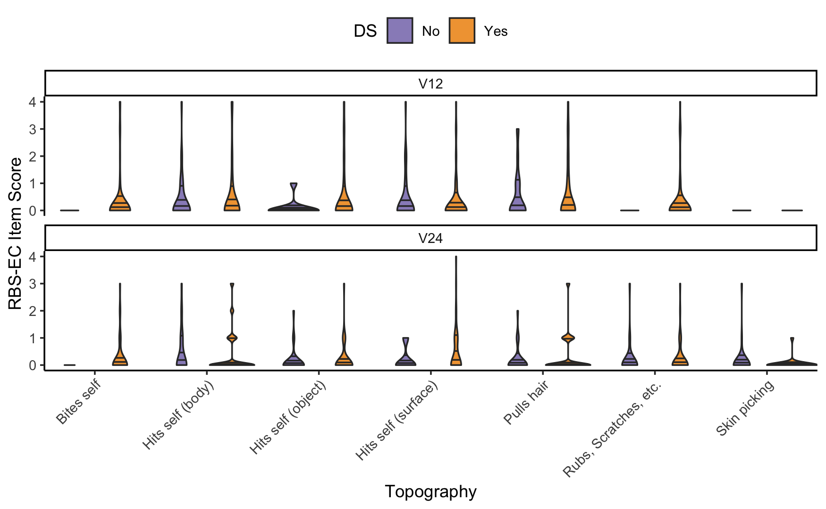
Note. Horizontal lines in the violins indicate the 25th, 50th, and 75th quartiles.

Figure 2
Spaghetti Plot of Individual and Group Mean RBS-EC Self-Directed Behavior Domain Scores at 12-Months and 24-Months of Age for Infants with and without Down Syndrome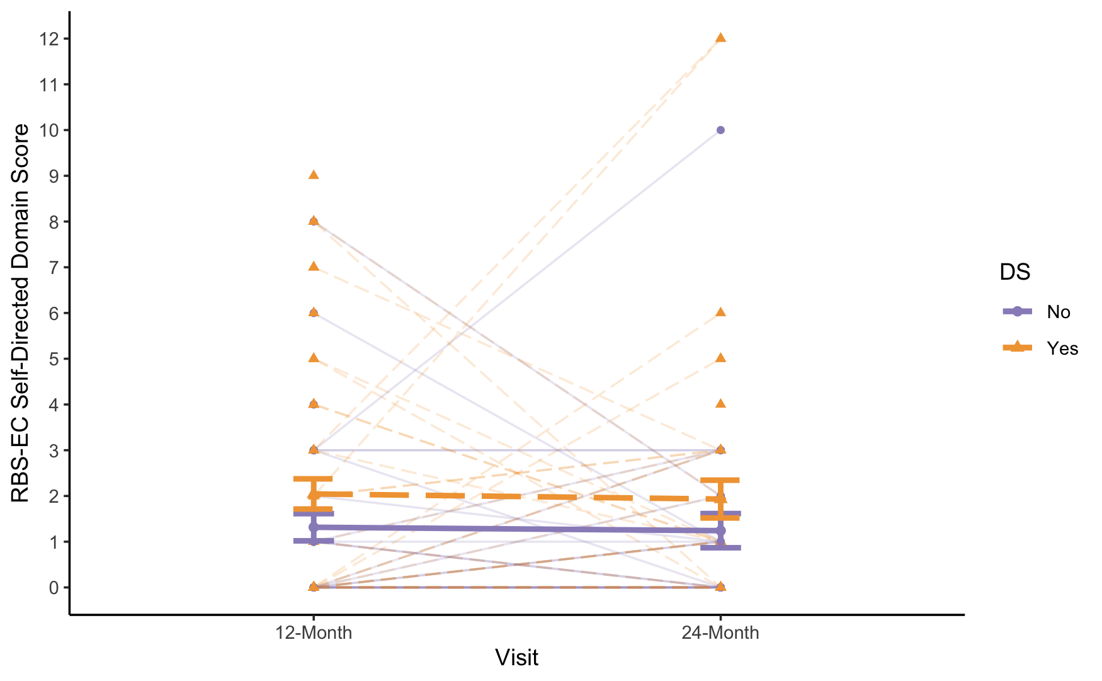Note. DS = Down syndrome; RBS-EC = Repetitive Behavior Scale for Early Childhood (Wolff et al., 2016); Orange, dashed lines with triangles indicate infants with DS. Purple, solid lines with circles indicate infants without DS. Bold lines indicate the change in group means. Standard error bars are included for group means at each time point. Faint lines indicate the change in scores for individual participants.

Paper 2 of 4
Paper Title: Self-Injury and developmental profiles in a sample of children with neurodevelopmental disabilities.
Authors: Jaclyn Gunderson, Breanne Byiers², Andrea Huebner⁹, Frank Symons²
Introduction: Self-injurious behavior (SIB) is a clinically challenging problem in neurodevelopmental disorders (Dimian et al., 2022) with increased prevalence noted in both autism spectrum disorder (ASD) and intellectual disability (ID) (Cervantes, et al., 2023). Less is known, however, about how developmental abilities associate with SIB. The current study examined SIB across neurodevelopmental conditions including autism spectrum disorder (ASD, n=33), intellectual disability (ID, n=21), and autism with intellectual disability (ASD+ID, n=43) and the relation to developmental characteristics such as physical, adaptive, social emotional, cognitive and communication abilities.
Method: Data were derived from a larger study of early sensory and self-injurious behavior in children with neurodevelopmental disabilities between the ages of 2-12 (M=73 months, SD=33 months, 67% Male). Caregiver report of SIB was measured the Repetitive Behavior Scale Early Childhood (RBS-EC) to determine the frequency of endorsement for behaviors and topographies of self-injury. The Developmental Profile 4th edition was used to measure standard scores in physical, adaptive, social emotional, cognitive and communication behavior. Correlation analyses and linear regression were used to identify variables that are associated with SIB.
Results: SIB was endorsed in 78.4% of the total sample. The prevalence of SIB was 67.6% in the ASD only group, 77.8% in the ID only group, and 88.7% in the ASD+ID group. Using linear regression sex, or age did not account for a significant amount of variance in SIB total scores or SIB interference scores. The presence of ID, with or without ASD was associated with higher SIB interference scores, but did not help explain total SIB scores. SIB total scores were negatively correlated with social emotional abilities (-.31, p =.009), while SIB interference scores negatively associated with physical (-.26, p=.037), social emotional (-.37, p=.001), cognitive (-.24, p=.04) and communication (-.28, p=.03) behaviors. Social emotional abilities significantly explained variance in both SIB total scores (10%) and SIB interference scores (15%) above and beyond diagnosis. Further, increased frequency of biting self and hitting self against surfaces were associated with the diagnosis of ID, while other specific topographies of SIB did not vary significantly by diagnostic group, sex, or age.
Discussion: Findings revealed that in the current sample, SIB is generally occurring frequently across ASD, ID, and ASD+ ID, however, SIB is estimated to interfere more with daily living and relationships in children with ID with or without ASD. Based on our results, variance in SIB frequency and interference were best estimated by differences in social emotional skills. Our results suggest that social emotional abilities (e.g., expression of emotion, moderating behavior in different environments, and understanding feelings) may be important treatment considerations. Future research should seek to further explore associations with the severity and functional purposes of self-injurious behavior.
This work was supported, in part, by Eunice Kennedy Shriver NICHD Grant No 44763
References
Dimian, A. F., & Symons, F. J. (2022). A systematic review of risk for the development and persistence of self-injurious behavior in intellectual and developmental disabilities. Clinical psychology review, 94, 102158.
Cervantes, P. E., Brown, D. S., & Horwitz, S. M. (2023). Suicidal ideation and intentional self-inflicted injury in autism spectrum disorder and intellectual disability: An examination of trends in youth emergency department visits in the United States from 2006 to 2014. Autism, 27(1), 226-243.
Paper 3 of 4
Title: Prospective characterization of age-related changes in self-injurious behavior in a sample of children with global developmental delay

Authors: Breanne Byiers², Jaclyn Gunderson⁹, Andrea Huebner⁹, and Frank J. Symons²
Introduction: Self-injurious behavior (SIB) is a common problem among individuals with intellectual and developmental disabilities (IDD) with significant impact on quality of life. Although some evidence suggests that SIB may increase with age, perhaps in a curvilinear pattern, this is primarily based on cross-sectional studies. Therefore, the purpose of the current study was to conduct a prospective, longitudinal analysis of age-related changes in a high-risk cohort of children with developmental disabilities/delays.
Method: A total of 110 participants, between 2 and 12 years of age at enrolment, were followed for between 2 and 4 years. Caregivers completed the RBS-EC SIB subscale annually, for a total of 317 assessments. The SIB total score, SIB interference ratings, and endorsement of specific SIB topographies were selected as dependent measures. Generalized linear models evaluating linear, quadratic, and cubic age-related changes, and differences by ID status (no/mild ID vs. moderate to profound ID) were created for each outcome
Results: For SIB total scores, the model suggested complex developmental patterns that varied by degree of ID. For SIB interference ratings, the model suggested that individuals with moderate to profound ID showed relatively high and stable levels of SIB interference across ages, whereas individuals with no or mild ID showed an increasing trend with age. Patterns varied across the specific SIB topographies.
Discussion: The results suggest that age-related changes in SIB are complex and may vary across topographies. Overall, the results are concerning in that they indicate a potentially increasing trend in frequency of SIB and its impact on daily activities as individuals approach adolescence, indicating the need for further longitudinal work across the lifespan.
Supported, in part, by Eunice Kennedy Shriver NICHD Grant No 44763
References:
Davies, L., & Oliver, C. (2013). The age-related prevalence of aggression and self-injury in persons with an intellectual disability: A review. Research in Developmental Disabilities, 34(2), 764-775. https://doi.org/10.1016/j.ridd.2012.10.004

Davies, L. E., & Oliver, C. (2016). Self-injury, aggression and destruction in children with severe intellectual disability: Incidence, persistence and novel, predictive behavioural risk markers. Research in Developmental Disabilities, 49, 291-301. https://doi.org/10.1016/j.ridd.2015.12.003

Dimian, A. F., & Symons, F. J. (2022). A systematic review of risk for the development and persistence of self-injurious behaviourin intellectual and developmental disabilities. Clinical Psychology Review, 94, 102-158. https://doi.org/10.1016/j.cpr.2022.102158.

Laverty, C., Oliver, C., Moss, J., Nelson, L., & Richards, C. (2020). Persistence and predictors of self-injurious behaviour in autism: a ten-year prospective cohort study. Molecular Autism, 11, 1-17. https://doi.org/10.1186/s13229-019-0307-z

Paper 4 of 4
Paper Title: Assessing the feasibility of the i-KNOW (identifying and knowing about behaviour) preventive intervention programme for individuals at high risk for behaviours that challenge
Authors: Walters, L. R¹., Williams, C. A^{1,}., Groves, L., Allen, D., Bain, D., Cooper, V., Daniel, L., Garstang, J¹³., Jones, C.¹, Kaur, K¹., Khan, A¹., Liew, A., McCleery, J., Oliver, C¹., Rose, J¹., Simkiss, D¹³., Richards, C¹.,
Introduction: Behaviours that challenge (BtC), such as self-injury and aggression, are common in individuals with intellectual disability (ID), with both prevalence and severity increasing with age (Emerson et al., 2014). The presence of BtC significantly impacts the quality of life of children with ID, contributing to higher rates of social exclusion, hospitalisation, and the use of intrusive reactive strategies (Beadle-Brown et al., 2009; Mandell, 2008). BtC also contribute to physical and emotional risks for caregivers (Emerson & Enfield 2011; McIntyre et al., 2002). Despite the substantial financial and human costs associated with BtC, interventions are typically implemented after behaviours emerge, rather than proactively (Groves et al., 2023). Therefore, early identification of individuals at risk of developing BtC and delivery of preventative interventions are crucial.
Method: This study employed a repeated measures design (pre- and post-intervention). Family caregivers of children aged one to eight years with confirmed or suspected developmental difficulties were screened for eligibility using a risk algorithm (i-RISC; Groves et al., in prep). Participants were stratified into two groups: the i-KNOW intervention workshops for those at high risk of developing BtC (n=50) and remote learning for those at moderate risk (n=13). Pre and post intervention questionnaires and semi-structured interviews were used to evaluate the feasibility and acceptability of the i-RISC algorithm and i-KNOW intervention in a National Health Service (NHS) clinical setting in the UK. This research informed a second feasibility study targeting parents and caregivers of children aged three and under in collaboration with the NHS in the UK. Six i-KNOW intervention workshops were implemented in this second trial, involving 36 parents and caregivers.
Results: Of the 845 carers sent recruitment information, 165 expressed interest and were screened, resulting in a 20% recruitment rate. Approximately 40% of participants who consented completed all six weeks of the i-KNOW intervention. There were no significant differences in caregiver efficacy or child behaviour pre and post intervention for the moderate risk group. However, in the high-risk group, caregivers reported significant improvements in their perception of behaviour, though no changes were noted in the frequency or severity of BtC. Additionally, caregivers in the high-risk group noted significant improvements in their child’s verbal and non-verbal communication following the intervention. Provisional results from the second feasibility study targeting suggest the i-KNOW intervention is acceptable and feasible for parents and caregivers of children aged three and under.
Discussion: These findings suggest that the i-KNOW intervention is feasible but requires refinement to improve retention across the intervention pathway. While significant changes in caregiver perception and child communication were observed in the high-risk group, early recruitment of younger children is essential to fully realise the preventative potential of the program.
References
Beadle-Brown, J., Mansell, J., Whelton, B., & Hutchinson, A. (2009). People with learning disabilities in ‘out-of-area’ residential placements: views of families, managers and specialists. The British Journal of Development Disabilities, 55(108), 15-31.
Emerson, E., Blacher, J., Einfeld, S., Hatton, C., Robertson, J., & Stancliffe, R. J. (2014). Environmental risk factors associated with the persistence of conduct difficulties in children with intellectual disabilities and autistic spectrum disorders. Research in Developmental Disabilities, 35(12), 3508-3517.
Emerson, E., & Einfeld, S. L. (2011). Challenging behaviour. Cambridge University Press.
Groves, L. (2023). Behaviours that challenge in people with intellectual disability (Doctoral dissertation, University of Leicester).
Groves, L., Davies, G, Oliver, C., Allen, D, Bamford, C. et al. (In prep). The development and validation of models of risk for behaviours of concern in children with developmental disabilities: a novel machine learning approach
Mandell, D. S. (2008). Psychiatric hospitalization among children with autism spectrum disorders. Journal of Autism and Developmental Disorders, 38, 1059-1065.
McIntyre, L. L., Blacher, J., & Baker, B. L. (2002). Behaviour/mental health problems in young adults with intellectual disability: The impact on families. Journal of Intellectual Disability Research, 46(3), 239-249.

School of Psychology, University of Birmingham, Birmingham, UK
University of Minnesota, Department of Educational Psychology, Minneapolis, MN
University of Minnesota
Washington University in St. Louis
University of Washington
University of North Carolina at Chapel Hill
Children’s Hospital of Philadelphia
University of Alberta
Mayo Clinic, Department of Pediatric and Adolescent Medicine, Rochester MN
Division of Psychiatry, University College London, London, UK
Birmingham and Solihull Mental Health NHS Foundation Trust, Birmingham, UK
University of Wolverhampton
Birmingham Community Foundation Healthcare Trust, Birmingham, UK
The Challenging Behaviour Foundation, Kent, UK
Forward Thinking Birmingham, Birmingham UK
South London and Maudsley NHS Foundation Trust, London, UK
Kinney Center for Autism Education and Support, Saint Joseph’s University

