**Title**:  **The Aberrant Behavior Checklist in FOXP1 syndrome: Effects of Age, Sex, and Autism Diagnosis**

**Authors**: Serena Cai, Dalia Marquez, Tess Levy, Hailey Silver, Joseph D. Buxbaum, Alexander Kolevzon, Paige M. Siper

**Introduction**: FOXP1 syndrome is a rare genetic disorder caused by mutations in the *FOXP1* gene and is associated with global developmental delay, mild to profound intellectual disability, speech and language impairment, autism spectrum disorder (ASD) and autism traits, attention-deficit/hyperactivity disorder (ADHD), and a range of behavioral challenges (Siper et al., 2017; Trelles et al., 2021). While recent studies increased general understanding of the clinical range of symptom presentations, there is little understanding regarding the natural history of the syndrome. The current study applies a cross-sectional approach to examine problem behaviors in individuals with FOXP1 syndrome from early childhood to adulthood.

**Method**: The Aberrant Behavior Checklist (ABC) was completed by the parent or caregiver of thirty-one individuals (*M* = 15.50 yrs, SD = 8.06) with FOXP1 syndrome between the ages of 5 and 35. 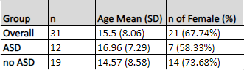The ABC is a 58-item caregiver questionnaire that measures problem behaviors in individuals aged five and older with developmental disabilities (Aman and Singh, 1986). These behaviors are categorized into five subscales: irritability, lethargy/social withdrawal, stereotypic behavior, hyperactivity, and inappropriate speech. Higher scores for each ABC subscale reflect a higher severity of problem behavior. A simple regression assessed the relationship between age and scores. Additionally, multiple regression models examined the effect of sex (male or female) and ASD diagnosis (no ASD or ASD). Regression model coefficients of each predictor variable and their corresponding p-values and 95% confidence interval values were calculated. All analyses were performed using R-Studio.

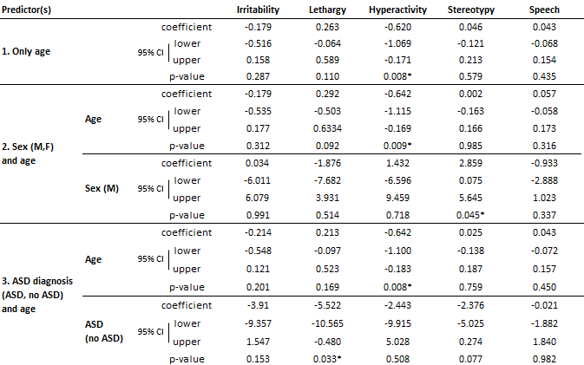**Results:** Hyperreactivity, irritability, and lethargy were the most commonly reported symptoms in this cohort. Hyperactivity (*M* = 19.77, *SD* = 10.76) significantly decreased with age (*p* = 0.008). There was no significant relationship with age for irritability (*M* = 11.42, *SD* = 7.31), stereotypy (*M* = 3.26, *SD* = 3.57) or inappropriate speech (*M* = 2.31, *SD* = 2.36). There was a trend suggesting lethargy (*M* = 6.39, *SD* = 7.25) may increase with age (*p* = 0.110). Sex was significantly correlated with stereotypy across age, as males tended to have higher scores than females (p = 0.045). Lastly, individuals with ASD had higher lethargy scores across age (p = 0.033) compared to those without ASD. No other relationships were identified between age or ASD diagnostic status.

**Discussion:** Findings from this study suggest irritability, stereotypy, and inappropriate speech scores were consistent across age, with high scores in the irritability domain suggesting its importance as a treatment target. The trend in increased lethargy/social withdrawal, particularly in the ASD group, is consistent with literaturesuggesting individuals with neurodevelopmental disorders tend to socially withdraw over time (Kwan et al., 2020). The decrease in hyperactivity scores isconsistent with studies in the broader ADHD population that reveal a decrease in symptoms over time (Faraone et al., 2005). Males exhibited higher stereotypic behaviors compared to their female counterparts, a finding seen previously in other neurodevelopmental conditions (Mandy et al., 2012) and contributes evidence to a potential sex-linked correlation in repetitive behaviors that warrants further exploration. Future studies with larger sample sizes are needed toexplore non-linear relationships between problem behavior and age, as well as the impact of medication status. Natural history studies are critical in understanding how these symptoms evolve within the same participants over time. Overall, these findings may prove useful to inform areas for evaluation and treatment while serving as a useful foundation for further research in FOXP1 syndrome.

**References:**

Aman, M. G., & Singh, N. N. (1986). Aberrant behavior checklist manual. East Aurora, NY: Slosson

Educational Publications.

Faraone S., Biederman J., Mick E. The age-dependent decline of attention deficit hyperactivity disorder: a meta-analysis of follow- up studies (2006). Psychological Medicine. 36(2):159-165. https:///doi.org/10.1017/S003329170500471X

Kwan, C., Gitimoghaddam, M., Collet, J.P. Effects of Social Isolation and Loneliness in Children with Neurodevelopmental

Disabilities: A Scoping Review (2020). *Brain Sci.* 10(11),786. <https://doi.org/10.3390/brainsci10110786>

Mandy, W., Chilvers, R., Chowdhury, U. et al. Sex Differences in Autism Spectrum Disorder: Evidence from a Large Sample of

Children and Adolescents (2012). *J Autism Dev Disord.* 42, 1304–1313. <https://doi.org/10.1007/s10803-011-1356-0>

Siper, P. M., De Rubeis, S., Trelles, M. D. P., Durkin, A., Di Marino, D., Muratet, F., Frank, Y., Lozano, R.,

Eichler, E. E., Kelly, M., Beighley, J., Gerdts, J., Wallace, A. S., Mefford, H. C., Bernier, R. A., Kolevzon, A., & Buxbaum, J. D. (2017). Prospective investigation of FOXP1 syndrome. *Molecular autism, 8*, 57. <https://doi.org/10.1186/s13229-017-0172-6>

Trelles, M. P., Levy, T., Lerman, B., Siper, P., Lozano, R., Halpern, D., Walker, H., Zweifach, J., Frank, Y.,

Foss-Feig, J., Kolevzon, A., & Buxbaum, J. (2021). Individuals with FOXP1 syndrome present with a complex neurobehavioral profile with high rates of ADHD, anxiety, repetitive behaviors, and sensory symptoms. *Molecular autism, 12*(1), 61. <https://doi.org/10.1186/s13229-021-00469-z>