**Title**: Executive Function and Quality of Life: The Mediating Role of Self-Determination

**Authors**: Jennifer R. Bertollo,1 Lauren Baczewski,1 K. Sharp,1 Alan H. Gerber,1 Hannah Behar,1 Caroline Candy,1,2 Chloe C. Neuman,1 Hannah Puckett,3 Andrea Lopez,1,4 Alyssa Verbalis,1 Cara E. Pugliese,1 & Lauren Kenworthy1

**Introduction:** Autistic individuals often experience difficulty with the executive function (EF) skills necessary for self-regulation and goal-directed behavior in daily life. Self-report of EF provides unique, valuable information about an individual’s skill profile, but is understudied and not consistently utilized in assessment and treatment for autistic individuals (Kenworthy et al., 2022). This is vital because a person’s perception of their EF abilities has clear implications for fostering or hindering their self-determination. Self-determination refers to the degree to which an individual feels that they have “causal agency” in their life, and theories of agentic development highlight that successful “self-regulation and goal-directed action" (i.e., core EF skills) are instrumental in increasing agency (Shogren et al., 2015; 2021). In addition to improving self-determination through strengthening EF skills and subsequent opportunities to successfully demonstrate these skills, including autistic individuals in the assessment of their own EF strengths and support needs inherently increases their motivation and agency in informing their own treatment plan and goals (Kenworthy et al., 2022; Shogren et al., 2021). This is crucial because self-determination improves quality of life (QOL) and facilitates more autonomous transition to adulthood in autism (Shogren et al., 2021; Test et al., 2009). To this end, the current study evaluated the link between self-reported EF and QOL, and whether self-reported self-determination mediates this relationship.

**Method:** 70 autistic teens and young adults ages 14.2 to 20.7 years (*M* = 16.2, *SD* = 1.2; 69% male; 71% White; 7% Hispanic/Latinx; full-scale IQ range = 61-141) completed three self-report measures at baseline for two treatment studies. EF was measured by the Behavior Rating Inventory of Executive Function, Second Edition (BRIEF-2) Global Executive Composite (GEC); higher scores indicate more EF challenges. Self-determination was measured by the American Institutes for Research Self-Determination Scale (AIR) Level (max = 120); a higher score indicates more self-determination. For each participant, QOL was averaged across 18 items derived from several research-based measures (i.e., ASQol, WHOQol-BREF, QOL-Q) to create a score from 1-5; higher scores indicate better QOL. Spearman’s correlations assessed bivariate relationships. Mediation analysis (Figure 1) was then conducted using SPSS 28 PROCESS macro, with BRIEF-2 GEC as the independent variable (X), QOL as the dependent variable (Y), and AIR Self-Determination Level as the mediator (M), with covariates of age, IQ, gender, and study, to account for differences between the two samples.

**Results:** More EF challenges were correlated with lower self-determination (*ρ* = -.558, *p* < .001) and QOL (*ρ* = -.439, *p* < .001). Self-determination and QOL were positively correlated (*ρ* = .668, *p* < .001). Mediation analysis revealed that weaker EF predicted lower QOL (*B =* -.022, 95% CI [-.033, -.011], *p* < .001), but self-determination mediated this relationship. The indirect effect was significant (*B* = -.016, 95% CI [-.024, -.009], *p* < .001) and the direct effect of EF was no longer significant when self-determination was included (*B* = -.006, 95% CI [-.017, .005], *p* = .307).

**Discussion:** These findings highlight an important potential pathway to improve QOL via EF and self-determination. Intervention to increase EF skills is likely to improve self-determination when teens have opportunities to demonstrate to themselves that they can successfully apply EF skills in daily life and ultimately achieve their goals more autonomously. Self-determination supports and strengths-based approaches may further augment EF treatment to facilitate self-determination and, in turn, improve QOL. Future analyses will evaluate these potential treatment mechanisms and mediators longitudinally in response to EF intervention.

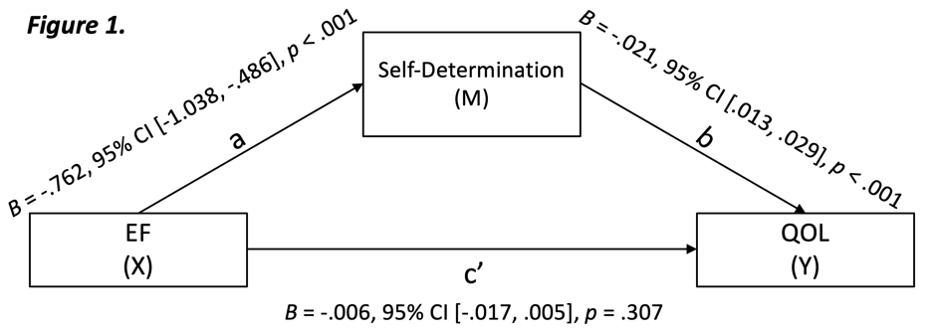

**References:**

Kenworthy, L., Verbalis, A., Bascom, J., daVanport, S., Strang, J.F., Pugliese, C., Freeman, A., Jeppsen., C., Armour, A.C., Jost, G., Hardy, K., & Wallace, G.L. (2022). Adding the missing voice: How autistic youth self-report on an executive functioning rating scale compares to parent report and that of youth with ADHD or neurotypical development. *Autism, 26*(2), 422-433. <https://doi.org/10.1177/13623613211029117>

Shogren, K.A., Mosconi, M.W., Raley, S.K., Dean, E.E., Edwards, B., Wallisch, A., Boyd, B., & Kiblen, J.C. (2021). Advancing the personalization of assessment and intervention in autistic adolescents and young adults by targeting self-determination and executive processes. *Autism in Adulthood, 3*(4), 289-299, <https://doi.org/10.1089/aut.2021.0010>

Shogren, K.A., Wehmeyer, M.L., Palmer, S.B., Forber-Pratt, A.J., Little, T.J., & Lopez, S. (2015). Causal agency theory: Reconceptualizing a functional model of self-determination. *Education and Training in Autism and Developmental Disabilities, 50*(3), 251-263.

Test, D. W., Mazzotti, V. L., Mustian, A. L., Fowler, C. H., Kortering, L., & Kohler, P. (2009). Evidence-based secondary transition predictors for improving postschool outcomes for students with disabilities. *Career Development for Exceptional Individuals, 32*(3), 160–181. <https://doi.org/10.1177/0885728809346960>

Center for Autism Spectrum Disorders, Children’s National Hospital, Washington, DC

2 Laboratory of Brain and Cognition, National Institute of Mental Health, Bethesda, MD

3 Developmental Cognitive Neuroscience Laboratory, George Washington University, Washington, DC

4 School of Education, Indiana University Bloomington, Bloomington, IN