Title: Autism, ADHD, AuDHD adults' falls & walking experiences in challenging environments
Authors: Julianna M. Hickey¹, Isabel Munoz Orozco, B.S. ¹, Dominique Kinnett-Hopkins, Ph.D. ¹, & Haylie L. Miller, Ph.D.¹
Introduction: Autistic people experience a higher incidence of falls and fall-related injuries than neurotypical individuals, likely due to undiagnosed and untreated motor problems that persist into adulthood (Gowen, Earley, Waheed, & Poliakoff, 2023; Linke, Kinnear, Kohli, Fong, Lincoln, Carper, & Müller, 2019). Evidence suggests that adults with ADHD also experience challenges with walking, particularly when attentional demands exceed a critical threshold (Saito, Ikeda, Okuzumi, & Kokubun 2017). However, little is known about effects of the combined presentation of autism and ADHD (AuDHD) on walking, and which specific environmental factors exacerbate or alleviate walking difficulty in each of these populations. We aimed to determine whether autistic, ADHD, and AuDHD adults experienced different rates of falls during walking, and whether they attributed difficulty with walking to different environmental features. We predicted that AuDHD participants would report the highest number of falls and resulting injuries, and that ADHD participants would report the lowest number of falls and resulting injuries.
Method: We recruited 43 adults from 16 countries via Prolific (Autism: n = 14, M = 8, W = 5, NB = 1, ADHD: n = 16, M = 8, W = 7, T = 1, AuDHD: n = 13; M = 5, W = 6, NB = 2). Autistic participants had a mean age of 26.21 yrs (range = 20-34), ADHD participants had a mean age of 33.69 yrs (range = 20-56), and AuDHD participants had a mean age of 28.35 yrs (range = 22-43). Data were collected in REDCap. Participants submitted one or more photos of environments they found challenging to walk in (Figure 1). 3 autistic, 4 ADHD, and 2 AuDHD participants submitted more than one unique environment. Participants estimated the number of times in the past year they had fallen in each environment, what percent of those falls resulted in an injury, and what percent of injuries they sought medical care for. We excluded 3 participants (2 AuDHD, 1 autistic) who did not give numerical fall estimates.
Results: We used an ANOVA to determine whether the mean number of falls differed by diagnostic group (autism, ADHD, AuDHD). There were no significant differences in falls by group, F(2, 51) = 1.03, p = 0.36. The autistic group reported a mean of 2.47 falls (Range = 0-10), the ADHD group reported a mean of 4.50 falls (Range = 0-25), and the AuDHD group reported a mean of 4.50 falls (Range = 0-11). Only 1 autistic, 3 ADHD, and 2 AuDHD participants reported seeking medical care after their fall. We also examined the frequency with which each group reported particular environmental elements as challenging (Table 1; sample sizes reflect the number of unique environments submitted).
Discussion: Contrary to our hypotheses, mean number of falls did not differ by group, and only a small number of participants reported being injured or having sought medical care as a result of these falls. The ADHD group had a notably wider range of falls reported, perhaps due to the wider age range of participants in this group. The three groups also reported relatively similar environmental elements as challenging for walking, with surface condition, visual conditions, auditory conditions, and obstacles posing the greatest challenges. However, there were several notable differences: the autistic group affirmed visual and auditory conditions and navigational concerns more often than the ADHD or AuDHD groups, and the AuDHD group affirmed personal factors and environmental novelty more often than the autistic or ADHD groups. Small sample size is a potential limitation of this study, although the sample was diverse in gender and geographic representation. Future studies of a larger sample should further assess the specific environmental features that contributed to falls, determine the role of age on fall frequency and severity, and identify factors that affect the level of fall severity and follow-up care.
References: Gowen, E., Earley, L., Waheed, A., & Poliakoff, E. (2023). From "one big clumsy mess" to "a fundamental part of my character." Autistic adults' experiences of motor coordination. PloS one, 18(6), e0286753.
Linke, A. C., Kinnear, M. K., … & Müller, R. A. (2020). Impaired motor skills and atypical functional connectivity of the sensorimotor system in 40- to 65-year-old adults with autism spectrum disorders. Neurobiology of aging, 85, 104–112.
Saito, R., Ikeda, Y., Okuzumi, H., & Kokubun, M. (2017). Heightened Attention Demand of the Walking Cancellation Task and Its Relation to ADHD Tendency in Young Adults, Journal of Special Education Research, 6(2), 81-89.
Figure 1. Example photos submitted by autistic, ADHD, and AuDHD participants.
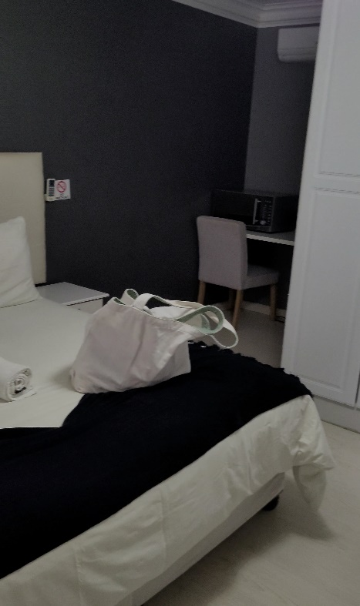 | 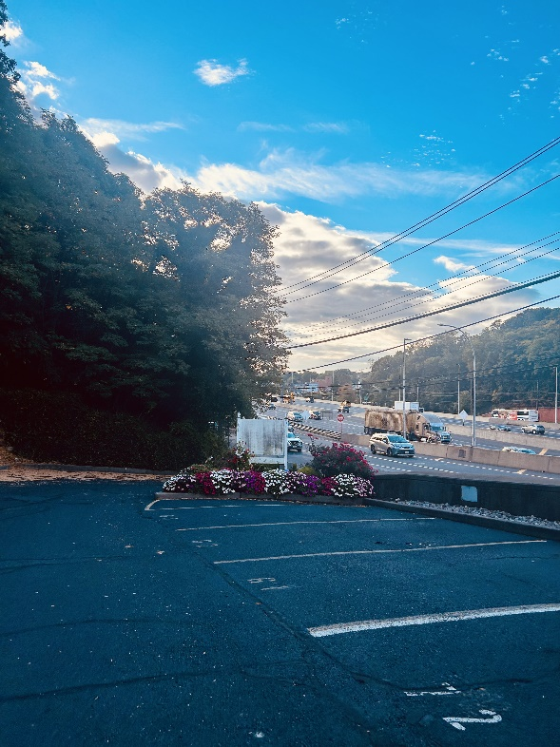 | 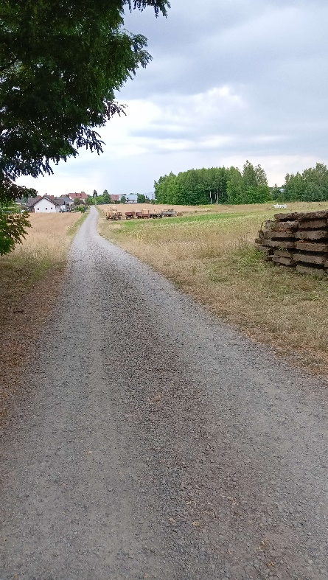
Autistic Example Photo  28 y.o. South African woman  “The way the furniture is set out does not provide enough room for me to maneuver.” | ADHD Example Photo  35 y.o. American man  “My building is a steep hill.” | AuDHD Example Photo  22 y.o. Polish nonbinary person  “[A lot of] holes that create with time due to cars [driving] and gravel being quite loose, hard to take steps when not looking at your feet constantly.”

Table 1. Frequency (%) of challenging environmental elements affirmed by diagnostic group
Group | Surface Conditions | Visual Conditions | Auditory Conditions | Personal Factors | Environmental Novelty | Navigational Concerns | Obstacles
Autism (n = 17) | 10 (58.82%) | 12 (70.59%) | 10 (58.82%) | 1 (5.88%) | 2 (11.76%) | 3 (17.65%) | 6 (35.29%)
ADHD (n = 20) | 13 (65.00%) | 10 (50.00%) | 7 (35.00%) | 2 (10.00%) | 2 (10.00%) | 0 (0.00%) | 8 (40.00%)
AuDHD (n = 17) | 11 (64.71%) | 8 (47.06%) | 6 (35.29%) | 6 (35.29%) | 4 (23.53%) | 1 (5.88%) | 4 (23.53%)

School of Kinesiology, University of Michigan

