Title: Exploring Measures of Excitatory/Inhibitory Balance in Individuals with Disruptive GRIN2B Mutations and Autistic and Non-Autistic Individuals without a Known Likely Gene Disrupting Mutation
Authors: Cramer-Benjamin, S¹, Pini, N.², Nelson, C.M.¹, Bernier, R.³, Neuhaus, E. ³, Eichler, E.E. ³, Webb, S.J. ³, Hudac, C.M.¹
Introduction: Disruptive mutations in the GRIN2B gene often result in atypical development of NMDA receptors leading to alteration in glutamatergic signaling and clinical phenotypes consistent with autism and intellectual disability ​(Sabo et al., 2023)​. The aperiodic exponent of the electroencephalography (EEG) power spectrum has been shown to be indirectly reflect balance in excitatory (glutamatergic) and inhibitory (GABAergic) neuronal balance (E/I); such that steeper (more positive) exponents are associated with greater power in the lower frequencies (inhibition) relative to power in the higher frequencies (excitation; ​Donoghue et al., 2020)​. Differences in aperiodic slope have been associated with a variety of rare genetic diagnosis, including Rett Syndrome which is known to affect GABAergic signaling ​(Roche et al., 2019)​ though there is mixed evidence surrounding differences between autistic and neurotypical participants ​(Webb et al., 2023).​ Given the well-documented differences in the glutamatergic pathway in GRIN2B, we hypothesize that the GRIN2B will express decreased aperiodic exponents compared to the iAUT and NT groups.
Method: Data collection took place across multiple studies with ascertainment based upon genetic status (i.e., mutation associated with autism; Table 1, diagnostic, genetic, and demographic information) or based upon autism diagnosis. Participants were instructed to sit quietly with eyes open while resting EEG was collected, for an average of 509.42 seconds (Range: 161.90s-958.35s). Data were processed using HAPPE ​(Gabard-Durnam et al., 2018)​. Per participant, aperiodic exponents were derived with Fitting Oscillations and One Over F (FOOOF; Donoghue et al., 2020) across the average of all usable segments. Participants were included if they had at least 30 seconds of usable EEG data (15 segments post-filtering) and a FOOOF model fit above .97.
Results: In a linear fixed effects model comparing the distributions of aperiodic exponent in GRIN2B, iAUT, and NT (reference) groups, there was not a main effect of group, when controlling for age, sex assigned at birth, and number of good segments (p=.35). There was a significant effect of age (F(1,157) =26.67, p<.0001) and a trending interaction between group and age (F(1,157) =2.54, p=.083; Figure 1). There were no effects of sex assigned at birth. In the GRIN2B, but not iAUT and NT groups, there was an effect of number of good segments (B=.002, p=.008).
Discussion: These data suggest that as participants age, the aperiodic exponent decreases (flattens), reflecting an increase in inhibition over excitation, likely due to neuronal maturation. The absence of group differences but significant interaction between number of good segments and age in GRIN2B indicates that differences in data quality across groups along with unbalanced sample sizes and age ranges may hinder our power to detect brain differences between GRIN2B, iAUT, and NT. These results provide preliminary deeper phenotyping of E/I in a rare genetic population with well-documented effects in the glutamatergic pathway. There is an ongoing need to examine E/I balance in GRIN2B across the lifespan and dive deeper into individual factors associated with changes in aperiodic exponents to determine the utility of E/I balance as a candidate non-invasive biomarker for GRIN2B and related disorders.
 | N (Female) | Mean Age (m) | Mean Age (Y) | Mean File Length (s) | Mean # Good Channels | Mean # Segments (2s) Post-Rejection
GRIN2B | 29 (15) | 96.97 | 8.12 | 350.52 | 112.84 | 131.59
Idiopathic autism (iAUT) | 62 (13) | 148.60 | 12.43 | 522.64 | 114.81 | 255.74
Neurotypical (NT) | 71 (26) | 137.20 | 11.48 | 562.50 | 113.89 | 275.85
Table 1. Demographic and EEG data quality information
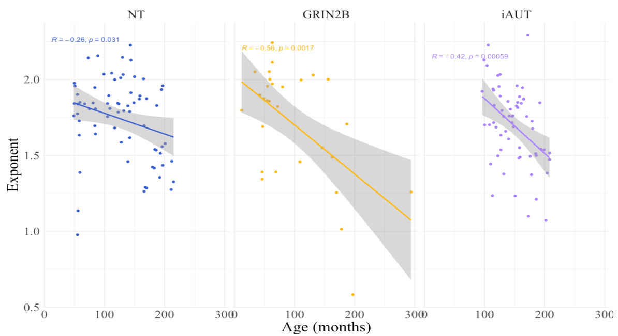
Figure 1. Relationship between age (months) and aperiodic exponent across groups. Smaller exponent values are thought to reflect greater contribution of excitatory over inhibitory neural activation.
References:
Donoghue, T., Haller, M., Peterson, E. J., Varma, P., Sebastian, P., Gao, R., Noto, T., Lara, A. H., Wallis, J. D., Knight, R. T., Shestyuk, A. & Voytek, B. (2020). Parameterizing neural power spectra into periodic and aperiodic components. Nature Neuroscience, 23(12), 1655–1665. https://doi.org/10.1038/s41593-020-00744-x
Gabard-Durnam, L. J., Leal, A. S. M., Wilkinson, C. L. & Levin, A. R. (2018). The Harvard Automated Processing Pipeline for Electroencephalography (HAPPE): Standardized Processing Software for Developmental and High-Artifact Data. Frontiers in Neuroscience, 12, 97. https://doi.org/10.3389/fnins.2018.00097
Roche, K. J., LeBlanc, J. J., Levin, A. R., O’Leary, H. M., Baczewski, L. M. & Nelson, C. A. (2019). Electroencephalographic spectral power as a marker of cortical function and disease severity in girls with Rett syndrome. Journal of Neurodevelopmental Disorders, 11(1), 15. https://doi.org/10.1186/s11689-019-9275-z
Sabo, S. L., Lahr, J. M., Offer, M., Weekes, A. L. & Sceniak, M. P. (2023). GRIN2B-related neurodevelopmental disorder: current understanding of pathophysiological mechanisms. Frontiers in Synaptic Neuroscience, 14, 1090865. https://doi.org/10.3389/fnsyn.2022.1090865
Webb, S. J., Naples, A. J., Levin, A. R., Hellemann, G., Borland, H., Benton, J., Carlos, C., McAllister, T., Santhosh, M., Seow, H., Atyabi, A., Bernier, R., Chawarska, K., Dawson, G., Dziura, J., Faja, S., Jeste, S., Murias, M., Nelson, C. A., … McPartland, J. C. (2023). The Autism Biomarkers Consortium for Clinical Trials: Initial Evaluation of a Battery of Candidate EEG Biomarkers. American Journal of Psychiatry, 180(1), 41–49. https://doi.org/10.1176/appi.ajp.21050485
University of South Carolina
2 Columbia University Irving Medical Center
3 University of Washington

