Title: Emergence of Restricted and Repetitive Behavior in Infants: An Analysis Across Neurodevelopmental Disorders Groups and Time
Authors: Phuong Tran¹, Emma Worthley¹, Kelly N. Botteron², Kelly E. Caravella³, Zumin Chen³, Stephen R. Dager⁴, Jed T. Elison¹, Annette M. Estes⁴, Heather C. Hazlett³, Robert T. Schulz⁵, Lonnie Zwaigenbaum⁶, Mark D. Shen³, Natasha N. Marrus², Joseph Piven³, John R. Pruett, Jr.², Jason J. Wolff¹ & IBIS Network
¹University of Minnesota; ²Washington University in St. Louis; ³University of North Carolina at Chapel Hill; ⁴University of Washington; ⁵Children’s Hospital of Philadelphia; ⁶University of Alberta

Introduction: Restricted and repetitive behaviors (RRBs) are common to both typical development as well as the behavioral phenotypes of many neurodevelopmental disorders (Lewis and Kim, 2009; Moss et al., 2008). These behaviors span simple motor stereotypies, such as hand flapping or body rocking, complex rituals and routines, and circumscribed interests, with constellations highly variable across syndrome groups (Moss et al., 2008; Wolff et al. 2014). However, little is yet known about the early development of RRB in infants and toddlers with syndromic neurodevelopmental disorders. In this present study, we investigated the early development of RRB in children across four different groups of neurodevelopmental disorders (autism spectrum disorder, ASD; Down syndrome, DS; fragile X syndrome, FXS; and Angelman syndrome, AS) and one comparison group (typically developing controls; TD). We hypothesized that groups would differ by developmental patterns of RRB topographies, with the ASD group showing the highest rates across the five topographies examined. Given a dearth of previous literature, our only specific hypothesis regarding the syndromic groups was that RRB would be elevated relative to TD.
Method: Data for ASD, DS, and TD used in this preliminary analysis was collected as part of the Infant Brain Imaging Study, an on-going prospective longitudinal study. Data for AS and FXS were collected as part of an IDDRC project at UNC. Families were recruited nationwide and assessed at one of five clinical data collection sites. RRB was measured using the Repetitive Behavior Scale for Early Childhood (RBS-EC; Wolff, Boyd, & Elison, 2016). Families completed an abbreviated, experimental version of the RBS-EC at age 6 months (T1). The experimental 6-month data were not available for the children with AS and FXS. The standard version of the same measure was administered at 12-month (T2) and 24-month (T3) visits. The sample included infants diagnosed with DS (Total N = 171, N_{T1} = 54, N_{T2} = 73, N_{T3} = 44), ASD (Total N = 94 , N_{T1} = 30 , N_{T2} = 31 , N_{T3} = 33), AS (Total N = 18 , N_{T2} = 9, N_{T3} = 9), FXS (Total N = 13, N_{T2} = 6, N_{T3} = 7), and TD controls (Total N = 119 , N_{T1} = 52 , N_{T2} = 38, N_{T3} =29). Participants’ diagnoses were confirmed using either genetic testing (DS, AS, FXS) or clinical best-estimate diagnosis (ASD). Data from the 6-month infant cohort was only included in our analysis of the motor sub-scale (RM). A Kruskal-Wallis H test was used to determine if there were differences in motor sub-scales across syndrome groups and the three timepoints (V-6months, V-12months, and V-24months). Mann-Whitney U tests were used to determine if there were statistical differences across syndrome groups and two timepoints ( V-12months and V-24months) other sub-scale scores (ritual and routine (RR), restricted interest and behavior (IB), and self-directed behavior (SDB) and combined total RBS score.
Results: Results of our analysis of the mean differences across syndrome groups indicated that there was a statistical difference (χ²(df = 4, N = 412) = 9.47, p = 0.05). Similar results were found in our analysis of the mean difference in motor sub-scale across timepoint visits (χ²(df = 2, N = 412) = 27.73, p < 0.001). Next, we analyzed the total RBS-EC score and remaining sub-scales using all the data from our 12-month and 24-month cohorts. Our result indicated that, in total RBS-EC total score, there was a statistically significant difference across syndrome groups (χ²(df = 4, N = 276) = 26.14, p < 0.001). There was also evidence suggesting that RBS-EC total score was lower in timepoint 2 (12 months visit) than timepoint 3 (24-month visit), U = 5659.5, p < 0.001. Lastly, our result demonstrated group differences across the RM, RR, and IB subscales and statistically significant change over time in the RR (p < 0.001) and IB (p < 0.05) scores.
Discussion: Results of the present analysis demonstrate that across neurodevelopmental disorders, differences in repetitive behaviors can be observed in infants as early as six months old. Notably, we found within our measure of repetitive motor, there were notable differences in stereotypical movements across syndrome groups and timepoint visits. Our results suggest that there may be an interaction between syndrome groups and time leading to unique developmental trajectories in RRB development. Contrary to our hypothesis, the highest levels of RRB were observed in the AS group. Little is known about RRB in AS and this may be an important area of study. Limitations include very small group sizes for the FXS and AS groups. Additionally, our sample size only contained four neurodevelopmental disorders groups. The next steps for this work include the incorporation of mixed effects modeling accounting for covariables as well as additional comparison groups.

Figure 1. Trajectories for repetitive motor subscale and overall RBS-EC scores across groups
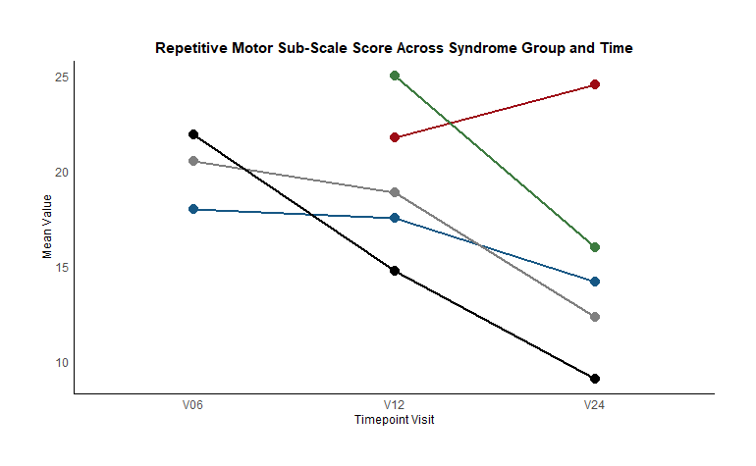
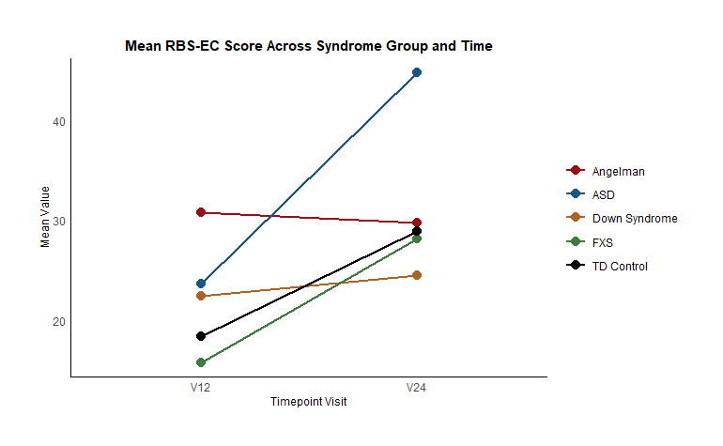

References: Lorem ipsum dolor sit amet, consectetur adipiscing elit
State University
2 University State

Figure 2. Mean value of motor subscale score across groups and time points.
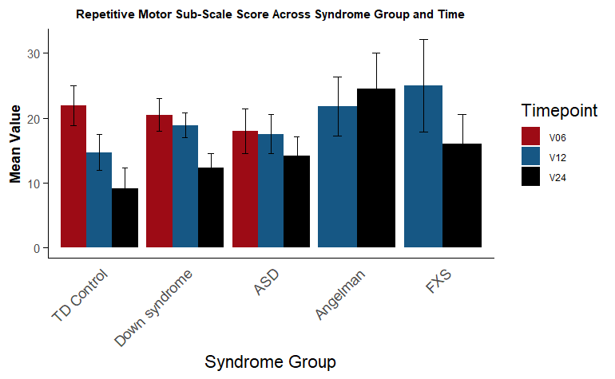

References
Lewis, M., & Kim, S. (2009). The pathophysiology of restricted repetitive behavior. Journal of Neurodevelopmental Disorders, 1(2), 114–132. https://doi.org/10.1007/s11689-009-9019-6
Moss, J., Oliver, C., Arron, K., Burbidge, C., & Berg, K. (2008). The prevalence and phenomenology of repetitive behavior in genetic syndromes. Journal of Autism and Developmental Disorders, 39(4), 572–588. https://doi.org/10.1007/s10803-008-0655-6
Wolff, J. J., Botteron, K. N., Dager, S. R., Elison, J. T., Estes, A. M., Gu, H., Hazlett, H. C., Pandey, J., Paterson, S. J., Schultz, R. T., Zwaigenbaum, L., & Piven, J. (2014). Longitudinal patterns of repetitive behavior in toddlers with autism. Journal of Child Psychology and Psychiatry, 55(8), 945–953. https://doi.org/10.1111/jcpp.12207
Wolff, J. J., Boyd, B. A., & Elison, J. T. (2016). A quantitative measure of restricted and repetitive behaviors for early childhood. Journal of Neurodevelopmental Disorders, 8(1). https://doi.org/10.1186/s11689-016-9161-x

