Title: Relations between Mastery Pleasure, Negative Affect, and Behavior Problems in Children with Williams Syndrome
Authors: Alecia Mercier¹, Brianna Paquette¹, Holley Pitts Arnold², Carolyn B. Mervis³, Caroline G. Richter¹
Introduction: Children with Williams syndrome (WS) tend to display unique temperament and behavioral profiles (Mervis & John, 2010). Certain elements of temperament and behavior problems have separately been linked to mastery motivation in typically developing (TD) children (Wang & Barrett, 2013), yet these relationships have not been explored in children with WS. Mastery motivation is a multifaceted, developmental construct often measured by two components, 1) persistence, the ability to master a moderately challenge task, and 2) mastery pleasure, the positive affect displayed during goal-directed behaviors (Barrett & Morgan, 2018). Although mastery pleasure is an important component of mastery motivation (Busch-Rossnagel & Morgan, 2013), most research has focused on persistence (Fung & Chung, 2023, Levine, 2000). Limited studies have shown that parent reported mastery pleasure is positively related to some aspects of temperament, including activity level (Morgan et al., 1988), and negatively related to some aspects of internalizing behaviors, including depressed mood (Morgan et al., 1990). No studies have examined the relations of mastery pleasure, whether assessed by parent report or objective, lab-based tasks, in children with WS, with temperament or problem behaviors. The aims of this study were 1) assess the relations between parent report and task-based measures of mastery pleasure in young school-aged children with WS and 2) examine the relations between task-based mastery pleasure, parent-report mastery pleasure, negative affect, and internalizing and externalizing behaviors in children with WS. Based on previous literature examining parent report mastery motivation using persistence in children with WS (Rowe, 2007), we hypothesize that parents of children with WS will report lower levels of mastery pleasure than TD norms.
Method: Participants were 32 6 – 8-year-old children with genetically confirmed classic-length deletions of the WS region. Mastery Pleasure was measured in two ways, 1) direct assessment using a performance-based task (adapted from Gilmore & Cuskley, 2009) and 2) parent report using the Mastery Pleasure subscale from the Dimensions of Mastery Quesionnaire-18 (DMQ; Morgan et al., 2020). For the task-based measure, mastery pleasure was defined as the percentage of task solutions for which children displayed a nonverbal or verbal expression of positive affect during task directed behaviors. The task was filmed, and behavioral coding of the first four minutes of each recording was conducted by two independent researchers (ICC= 0.99, p < .001) using Behavioral Observation Research Interactive Software (BORIS; Friard & Gamba, 2016). Negative affect was measured by parent report using the Children's Behavior Questionnaire’s Negative Affectivity Factor (CBQ; Rothbart et al., 2001). Behavior problems were measured by parent report using the Internalizing and Externalizing factors of the Child Behavior Checklist 6-18 (CBCL; Achenbach & Rescorla, 2001).
Results: Descriptive statistics are reported in Table 1. Children with WS evidenced considerable variability in the amount of mastery pleasure displayed in the task-based measure of mastery pleasure. Task-based verbal and nonverbal mastery pleasure were significantly correlated (r = .49, p = .005). Neither verbal (r = .09, p = .624) nor nonverbal (r = .29, p = .105) task-based mastery pleasure was related to parent report mastery pleasure (DMQ). Based on parent report, mean DMQ Mastery Pleasure score was significantly lower for the WS group (M = 4.45, SD = .50) compared to the TD norms (M = 4.62, SD = .47), t (31) = -1.90, p = .033, d = -.34. Correlation analyses were first conducted to further determine the extent of the relation between mastery pleasure, negative affect, and behavior. Higher reported levels of negative affect was related to higher levels of internalizing problems (r = .423, p = .016). Bivariate correlations among the variables are reported in Table 2.
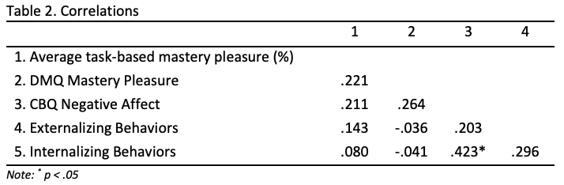
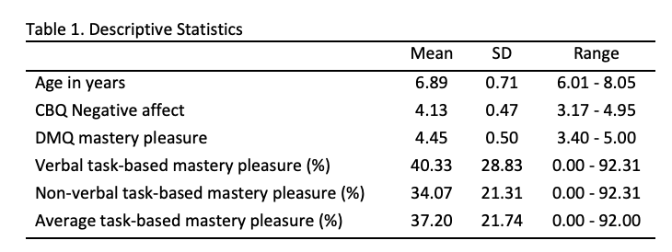
Discussion: Our study offers a unique contribution to the field by further characterizing mastery motivation in young school-aged children with WS through the examination of mastery pleasure using both task-based and parent report measures. Similar to persistence (Rowe, 2007), compared to TD children, children with WS exhibited significantly less mastery pleasure. The significant correlation between verbal and nonverbal mastery pleasure suggests that these forms of expression are closely linked in young school-aged children with WS, consistent with prior results for preschoolers with WS (Rowe, 2007). Consistent with previous studies of TD children (Barret & Morgan, 2018) and children with Down Syndrome and WS (Rowe, 2007), we found a discrepancy between parent report and task-based measures, highlighting the potential differences in overt displays of mastery pleasure in lab-based tasks measured by researchers compared to the daily home behaviors parents witness. Our findings expand on previous TD literature (Mikolajewski et al., 2013; Morales et al., 2022) by showing that negative affect is related to internalizing problems in children with WS. Contrasting previous work with TD children (Wang & Barrett, 2013; Morgan et al., 1990), we did not find a relation between mastery pleasure, whether parent report or task-based, and negative affect or temperament. Future research should consider how mastery pleasure differs in children with WS compared to TD children and the possibility that persistence rather than mastery pleasure may impact these constructs. Future work should aim to include larger sample sizes and comparison groups, as well as investigate the potential relations of mastery pleasure with other important outcomes, such as well-being and achievement.

References:
Achenbach, T. M. & Rescorla, L. A. (2001). Manual for the ASEBA School-Age Forms & Profiles. Burlington, VT; University of Vermont Research Center for Children, Youth & Families.
Barrett, K. C., & Morgan, G. A. (2018). Mastery motivation: Retrospect, present, and future directions. In Advances in Motivation Science (Vol. 5, pp. 1–39). Elsevier. https://doi.org/10.1016/bs.adms.2018.01.002
Busch-Rossnagel, N. A., & Morgan, G. A. (2013). Introduction to section three: Overview and analysis. In Handbook of self- regulatory processes in development: New directions and international perspectives (pp. 247–264). Psychology Press.https://doi.org/10.4324/9780203080719.ch12
Friard, O., & Gamba, M. (2016). BORIS: A free, versatile open-source event-logging software for video/audio coding and live observations. Methods in Ecology and Evolution, 7(11), 1325–1330. https://doi.org/10.1111/2041-210X.12584
Fung, W. K., & Chung, K. K. H. (2023). Longitudinal association between children’s mastery motivation and cognitive school readiness: Executive functioning and social-emotional competence as potential mediators. Journal of Experimental Child Psychology, 234, 105712. https://doi.org/10.1016/j.jecp.2023.105712
Gilmore, L., & Cuskelly, M. (2009). A longitudinal study of motivation and competence in children with Down syndrome: Early childhood to early adolescence. Journal of Intellectual Disability Research, 53(5), 484–492. https://doi.org/10.1111/j.1365-2788.2009.01166.x
Levine, S. L. (2000). Mastery motivation and child behavior problems [Ph.D., University of Miami]. https://www.proquest.com/docview/304607951/abstract/D8C1DBB24C714B83PQ/1
Mervis, C. B., & John, A. E. (2010). Cognitive and behavioral characteristics of children with Williams syndrome: Implications for intervention approaches. American Journal of Medical Genetics. Part C, Seminars in Medical Genetics, 154C(2), 229–248. https://doi.org/10.1002/ajmg.c.30263.
Mikolajewski, A.J., Allan, N.P., Hart, S.A., Lonigan, C.J. & Taylor, J. (2013). Negative Affect shares genetic and environmental influences with symptoms of childhood internalizing and externalizing disorders. Journal of Abnormal Child Psychology, 41(3), 411-423. https://doi.org/10.1007/s10802-012-9681-0
Morales, S., Tang, A., Bowers, M.E., Miller, N.V., Buzzell, G.A., Smith, E., Seddio, K., Henderson, H. Fox, N.A. (2022). Infant temperament prospectively predicts general psychopathology in childhood. Development and Psychopathology, 34(3), 774-783. https://doi:10.1017/S0954579420001996
Morgan, G.A., Maslin, C.A., Ridgeway, D., & Kang-Park, J. (1988). Toddler mastery motivation and aspects of mother-child affect communication. Program and Proceedings of the Developmental Psychobiology Research Group Retreat, 5, 15-16.
Morgan, G.A., Maslin-Cole, C.A., Downing, K., & Harmon, R.J. (1990). Antecedents of mastery and prediction of behavior problems (summary). Program and Proceedings of the Developmental Psychobiology Research Group Fifth Biennial Retreat, 5, 15-16.
Morgan, G. A., Liao, H. F., & Józsa, K. (2020). Assessing mastery motivation in children using the Dimensions of Mastery Questionnaire (DMQ). Szent István University. Gödöllő, Hungary
Rothbart, M. K., Ahadi, S. A., Hershey, K. L., & Fisher, P. (2001). Investigations of temperament at three to seven years: The Children’s Behavior Questionnaire. Child Development, 72(5), 1394–1408. https://doi.org/10.1111/1467-8624.00355
Rowe, M. L. (2007). Mastery motivation in young children with Williams syndrome or Down syndrome. [Doctoral Dissertation, University of Louisville]. https://www.proquest.com/docview/304837706/abstract/8AACF22C8334EFDPQ/1
Wang, J., & Barrett, K. C. (2013). 15 Mastery motivation and self-regulation during early childhood. In K.C. Barrett, N.A. Fox., G.A. Morgan, D.J. Fidler, L.A. Daunhauer (Eds.) Handbook of self-regulatory processes in development (pp. 337-380). Psychology Press.

University of Alabama at Birmingham
2 University of South Carolina
3 University of Pennsylvania

