Title: Advancing Measurement of Social Motivation: Evaluation of the Social Motivation Questionnaire in Infants with Down Syndrome and at High and Low Familial Likelihood of Autism Spectrum Disorder
Authors: Holly Baer,¹ Deena Iqubal,¹ Carolyn Lasch,¹ Annette Estes,² Stephen Dager,² Jed T. Elison,³ Chimei Lee, ³ Juhi Pandey,⁴ Robert Schultz,⁴ Lonnie Zwigenbaum,⁵ Rebecca Grzadzinski,⁶ Heather Hazlett,⁶ Kelly Botteron,¹ Joseph Piven,⁶ John R. Pruett, Jr.¹ & Natasha Marrus¹ on behalf of the IBIS Network
Introduction: Social motivation (SM), the predisposition to preferentially orient to social stimuli and to seek and maintain social engagement [1], is theorized to promote the development of social communication, and disrupted infant SM is hypothesized to contribute to subsequent social communication symptoms in autism spectrum disorder (ASD). Previously, we demonstrated favorable psychometric properties for a novel parent-report Social Motivation Questionnaire (SMQ) [2], as well as predictive validity of an SM metric for ASD in a sample enriched for infants at high familial likelihood for ASD [3]. To advance SM measurement development, we have applied the SMQ in a new sample of infants at high and low likelihood for ASD and a sample of infants with Down syndrome (DS), which is associated with increased frequency of ASD and social communication difficulties in addition to intellectual disability [4]. Objectives were to evaluate the SMQ’s performance in a sample enriched for children with significant cognitive delays and to test for replication of predictive validity for ASD in infants at high familial likelihood of ASD.
Method: Infants participated in the Infant Brain Imaging Study-Early Prediction (IBIS-EP), a multisite prospective study of infants at high familial likelihood (HL) for ASD and IBIS-DS, which included infants with DS and low familial likelihood (LL) controls. HL infants had an older sibling with ASD; LL infants had no 1st or 2nd degree relatives with ASD or intellectual disability. Assessments were conducted at 6, 12, and 24 months, followed by a 24-month clinical best estimate of ASD diagnosis according to the DSM-IV-TR checklist. Measures included age-appropriate versions of the SMQ and the Bayley Infant Scales of Development, 4th edition to assess cognitive development. Analyses compared four groups: LL-noASD controls (n=55), HL-noASD (n=164), HL-ASD (n=44), and DS-noASD (n=78). To maximize statistical power at an intermediate stage of data collection, 24-month clinical best estimates were not required for inclusion in analyses. Evaluation of SMQ measurement properties included visualization of score distributions, Cronbach’s α to index internal consistency, and cross-age correlations to examine temporal stability. Group differences were evaluated using t-tests and Cohen’s d effect sizes. Linear regressions tested relationships between infant groups and SMQ scores while controlling for cognitive development.
Results: SMQ scores were continuously distributed at 6, 12, and 24 months, with high overlap across groups and increased frequency of low scores at 24 months, an age of ASD symptom consolidation (Fig. 1). At all ages, Cronbach’s α was >0.95 and strong cross-age correlations (p’s<.001) were observed from 6-12 months (r=0.60), 12-24 months (r=0.63), and 6-24 months (r=0.52). The LL-noASD and HL-noASD groups showed the highest SMQ scores, with no significant differences at any age. The DS-noASD and HL-ASD groups showed lower scores than the LL-noASD group at all ages, with large effect sizes: DSnoASD, d=-0.75 to -0.97; HL-ASD, d=-0.79 to -1.29, p’s<.001. Cognitive development was substantially lower at all ages in infants with DS vs. LL-noASD (d’s= -2.2 to -3.3, p’s<.001), and when controlling for cognition in regression models (Table 1), DS-noASD status was not associated with lower SMQ scores at 12 and 24 months. In contrast, HL-ASD status was associated with lower SMQ scores at all three ages when controlling for cognitive development.
Discussion: Findings preliminarily suggest SM is measurable in infancy across a range of cognitive abilities and familial ASD liability. DS was associated with lower scores than the LL-noASD group; however, attenuation of this effect when accounting for cognition implies potential relationships between developmental level and the ability to demonstrate a broad repertoire of SM-related behaviors in infancy. Consistent with prior observations, predictive validity for ASD was supported in HL-ASD infants, even when accounting for cognitive level. Future directions include re-testing these effects with further data collection, including ASD outcome data in the DS group, investigating opportunities to optimize SMQ items for conditions with substantial differences in cognitive development, and exploring predictive validity of brain-behavior relationships for infant SM and later ASD.
References: 1. Chevallier, et al. (2012). The social motivation theory of autism. TiCS, 16(4), 231-239. 2. Davis, et al. Initial Psychometrics of an Early Childhood Social Motivation Questionnaire and Differentiation of Children with ASD. Oral presentation, 2021 Annual INSAR Meeting. 3. Marrus, et al. (2024). Social motivation in infancy is associated with familial recurrence of ASD. Dev. Psychopathol., 36(1), 101-111. 4. Channell, et al. (2015). Patterns of autism spectrum symptomatology in individuals with Down syndrome without comorbid autism spectrum disorder. J. Neurodev. Disord., 7(5).

Washington University in St. Louis
2 University of Washington in Seattle
3 University of Minnesota, Twin Cities
⁴ Children’s Hospital of Philadelphia
⁵ University of Alberta
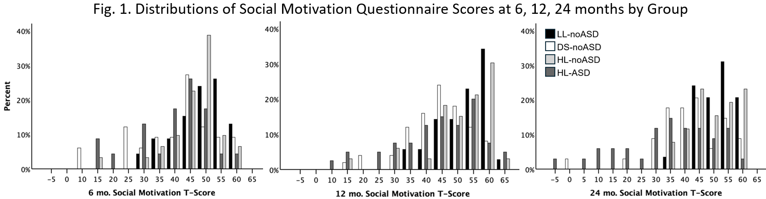
⁶ University of North Carolina, Chapel Hill

