Title: The Impact of COVID-19 on Latine Caregivers’ Vaccination Attitudes for Children with and without Autism
Authors: Catherine A. Patino-Celedon; Danica L. Limon-Mialkowski; Brooke Buranosky; Mikle South; Rebecca Lundwall; Robin P. Goin-Kochel
Introduction: In 2021, Latine individuals were among the least vaccinated groups for COVID-19 in the United States (Piedra et al., 2022). In particular, Latine children aged 5-11 had among the lowest rates for vaccination at 28.8%, compared to their Black (33.6%) and Asian (63.4%) counterparts (Valier, 2023). Simultaneously, Latine individuals were exposed to COVID at disproportionate rates (46%) compared to Asian (36%) and white individuals (33%) (Robertson et al., 2022). Our previous research (Limon-Mialkowski et al., 2024) indicated that Latine caregivers with an autistic child (ASD group) were more likely to be vaccine hesitant (VH) toward early-childhood vaccines compared to caregivers with a non-autistic child (NA group). However, there is limited information about Latine caregivers’ perceptions about COVID-19 vaccines for their children, particularly those with ASD. Considering the significant morbidity and mortality associated with COVID-19 and the increased risk for exposure among Latine communities, it is important to determine whether Latine children with ASD are at further risk for COVID-19 under vaccination. The objective of this poster is to (1) Compare Latine caregivers’ hesitancy toward COVID-19 vaccines between ASD and NA groups; (2) Assess congruence in their hesitancy toward both childhood vaccines and COVID-19 vaccines.
Method: Participants were 201 Spanish-speaking Latine caregivers living in the U.S. who completed a survey on their attitudes toward childhood vaccines between March 2022 - June 2024. VH was measured with the Spanish version of the Parent Attitudes about Childhood Vaccines (PACV). The PACV specifically instructs caregivers not to consider seasonal vaccines (e.g., influenza) when completing the form. For this reason, and because the COVID-19 vaccine became available for children younger than 5 in June 2022 (3 months after our survey went live), we included items querying child receipt of a COVID-19 vaccine (for those aged 5 and older) or caregiver intent to obtain a COVID-19 vaccine for their child when it became available (for those younger than 5). Chi-square analysis was used to assess potential discrepancies in parents’ willingness to vaccinate their children against COVID-19 across different age groups (0-4, 5-11, 12-17) between ASD and NA groups. We also used chi-square analysis to examine whether VH caregivers (per the PACV) were less likely to vaccinate or intend to vaccinate their children for COVID-19 compared to non-VH caregivers, regardless of diagnostic status.
Results: There were no significant differences between ASD and NA groups for COVID-19 vaccination/intent to vaccinate in any age category (0-4 years, 5-11 years, 12-17 years). However, VH caregivers were less likely to vaccinate their child with the COVID-19 vaccine for the 0-4 (p=0.004), and 5-11 (p=0.030) age groups but not the 12-17 age group (p=0.509). VH caregivers were also less likely to vaccinate themselves against COVID-19 (p=0.005).
Discussion: Our results suggest that Latine caregivers were more reluctant to vaccinate their child against COVID-19 if they were VH toward early childhood vaccines and their child was in early or middle childhood. However, there were no differences in COVID-19 vaccination rate between the ASD and NA groups. This is noteworthy considering that our previous investigation observed higher rates of VH toward early childhood vaccines in the ASD versus NA group. Latine caregivers may value (a) the safety and/or efficacy of vaccines differently for younger versus older children and/or (b) COVID-19 vaccines differently from routine childhood vaccines, some of which have been erroneously implicated as the cause of ASD. Findings suggest that healthcare professionals should be attuned to VH among Latine caregivers of young children and be prepared to address concerns/encourage vaccine uptake for all recommended vaccines.
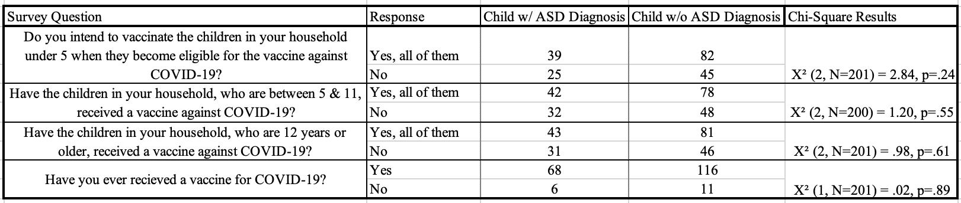
References:
Limon-Mialkowski, D. L., Patino-Celedon, C. A., Normansell-Mossa, K., Montiel-Nava, C., South, M., Lundwall, R., Goin-Kochel, R. P. (2024, May 15 - May 18). A Look into Vaccine Perceptions in U.S. Spanish-Speaking Families with and without an Autistic Child [Poster presentation]. Annual Meeting of the International Society for Autism Research, Melbourne, Australia. https://cdn.ymaws.com/www.autisminsar.org/resource/resmgr/docs/annualmeeting/abstract_book_2024.pdf
Piedra, L. M., Howe, M. J. K., Francis, J., Montoya, Y., & Gutwein, M. (2022). Latinos and the Pandemic: Results from the National Social Life, Health, and Aging Project—COVID-19 Study. Journal of Applied Gerontology, 41(5), 1465–1472. https://doi.org/10.1177/07334648211066920
Robertson, M. M., Shamsunder, M. G., Brazier, E., Mantravadi, M., Zimba, R., Rane, M. S., Westmoreland, D. A., Parcesepe, A. M., Maroko, A. R., Kulkarni, S. G., Grov, C., & Nash, D. (2022). Racial/Ethnic Disparities in Exposure, Disease Susceptibility, and Clinical Outcomes during COVID-19 Pandemic in National Cohort of Adults, United States—Volume 28, Number 11—November 2022—Emerging Infectious Diseases journal—CDC. https://doi.org/10.3201/eid2811.220072
Valier, M. R. (2023). Racial and Ethnic Differences in COVID-19 Vaccination Coverage Among Children and Adolescents Aged 5–17 Years and Parental Intent to Vaccinate Their Children—National Immunization Survey–Child COVID Module, United States, December 2020–September 2022. MMWR. Morbidity and Mortality Weekly Report, 72. https://doi.org/10.15585/mmwr.mm7201a1

