Title: Can Caregiver Worry Indicate Social-Emotional and Behavior Problems and Competence Delays?

Authors: Sarah Heath¹, Lara Cunningham¹, Mariela Jimenez¹, Chris Sheldrick², Abbey Eisenhower¹, and Alice Carter¹

Introduction: Children with developmental delays in Early Intervention (EI) typically show elevated social-emotional behavior (SEB) problems and delays in SEB competencies (Briggs-Gowan & Carter, 2007). Assessing caregiver worry about SEB problems and delays in SEB competencies is critical, as it can prompt service-seeking and guide discussions about SEB screening results (Godoy et al., 2013). However, there is considerable variability in how EI identifies and addresses these concerns (Smith et al., 2020). There is interest in improving the identification of children with mental health needs and the mental health services that they provide.

Method: Our sample included 2,422 children from a diverse larger multi-stage screening study (See Table 1). The children were screened using the Brief Infant-Toddler Social and Emotional Assessment (BITSEA) (Briggs-Gowan & Carter, 2006 ) a nationally normed screening tool for 12–36-month-olds, which was administered to assess SEB problems (e.g., “often gets upset”) and SEB competencies (e.g., “follows rules”) on a 3-point scale (0=Not true of my child/Rarely, 1=Somewhat True/Sometimes, 2=Very true/Often). The BITSEA also includes a question about parental worry about SEB (e.g., “How worried are you about your child’s behavior, emotions, and relationships?”) rated on a four-point scale (1=Not at all worried, 2= A little worried, 3=worried, and 4=Very worried). Using cut-scores based on these percentiles, four SEB groups were created: 1) “Of Concern” in Problems only, 2) “Of Concern” in Competencies only, 3) “Of Concern” in both Problems and Competencies or 4) no “Of Concern” scores.

Results: There was a statistically significant association between “Of Concern” BITSEA scores and parental worry (𝜒2 (6, N = 2,423 = 849.300, p < .01). Overall, approximately half (51.4%) of the caregivers reported “Of Concern” BITSEA scores, including “Of Concern” in SEB problems only (17%), “Of Concern” SEB competencies only (14%), or “Of Concern” scores for both SEB problems and competencies (20.5%). Of caregivers who reported “Of Concern BITSEA scores 32.6% indicated being worried to very worried. Overall,17.9% of caregivers reported being worried or very worried about their children; 92.6% of these worried caregivers also reported “Of Concern” BITSEA scores. Notably, over half (53.6%) of caregivers who reported no worry (29.5%), or a little worry (66.9%) had “Of Concern” scores for SEB problems and/or delays in competencies.

Discussion: Most caregivers who reported elevated SEB problems and reduced SEB competencies did not report worry, indicating that caregiver-reported worry alone is not a reliable indicator of SEB problems and/or SEB competencies. Hence, providers should not rely on caregiver worry alone to identify children with clinically significant SEB problems and delays. Identifying and addressing elevated SEB problems and delays in competencies among children receiving early intervention is essential as they can interfere with developmental gains (Chavez et al., 2024).
References:
Briggs-Gowan, M. J., & Carter, A. S. C. (2006). BITSEA: Brief infant-toddler social and emotional assessment. PsychCorp.
Briggs-Gowan, M. J., & Carter, A. S. (2007). Applying the Infant-Toddler Social & Emotional Assessment (ITSEA) and Brief-ITSEA in early intervention. Infant mental health journal, 28(6), 564–583. https://doi.org/10.1002/imhj.20154
Chavez, A. E., Troxel, M., Sheldrick, R. C., Eisenhower, A., Brunt, S., & Carter, A. S. (2024). Child social-emotional and behavioral problems and competencies contribute to changes in developmental functioning during Early Intervention. Early Childhood Research Quarterly, 66. https://doi.org/10.1016/j.ecresq.2023.10.009
Godoy, L., Mian, N. D., Eisenhower, A. S., & Carter, A. S. (2013). Pathways to Service Receipt: Modeling Parent Help-Seeking for Childhood Mental Health Problems. Administration and Policy in Mental Health and Mental Health Services Research, 41(4), 469–479. https://doi.org/10.1007/s10488-013-0484-6
Smith, S., Ferguson, D., Burak, E., Granja, M., & Ortuzar, C. (2020). Supporting Social-Emotional and Mental Health Needs of Young Children Through Part C Early Intervention: RESULTS OF A 50-STATE SURVEY National Center for Children in Poverty. https://www.nccp.org/wp-content/uploads/2020/11/Part-C-Report-Final.pdf

University of Massachusetts Boston
2 University of Massachusetts Chan Medical School

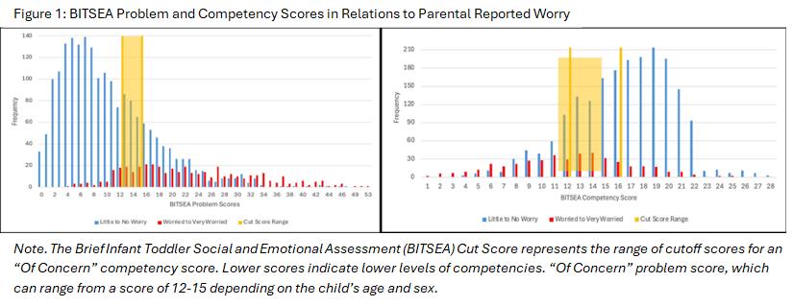
Table 1:Child Demographics
Demographic Variables |  | n |  | %
Child Sex
Male |  | 1,589 |  | 65.6
Female |  | 833 |  | 34.4
Age (in months)
12-18 |  | 486 |  | 20.1
19-24 |  | 827 |  | 34.1
25-30 |  | 766 |  | 31.6
31-36 |  | 343 |  | 14.2
Primary Language
English |  | 1,544 |  | 63.9
Spanish |  | 471 |  | 19.5
Other |  | 403 |  | 16.6
Race & Ethnicity
White, non-Latiné |  | 567 |  | 32.8
Black/African American |  | 575 |  | 24.1
White, Latiné |  | 265 |  | 11.1
Black, Latiné |  | 110 |  | 4.6
Latiné (unspecified) |  | 571 |  | 24.0
Asian |  | 133 |  | 5.6
Multiracial/Multiethnic |  | 120 |  | 5.0
Other |  | 43 |  | 1.8
Insurance Type
Public |  | 1,410 |  | 35.3
Private |  | 770 |  | 64.7

