Title: Racial and Ethnic Disparities in Access to Augmentative and Alternative Communication Among Families of Minimally Verbal Children with Autism Spectrum Disorder
Authors: Madeleine Hare¹, Shafali Jeste¹, Emily McFadd ¹, & Charlotte DiStefano¹
Introduction: Approximately 30% of individuals with autism spectrum disorder are minimally verbal, meaning they have little to no spoken language (Tager‐Flusberg & Kasari, 2013). Augmentative and Alternative Communication (AAC) refers to a variety of methods that help these individuals communicate. AAC has been shown to increase a minimally verbal individuals’ capacity to communicate and promote further spoken language (DiStefano et al., 2016). However, families often report challenges accessing the devices. Past research has shown that Black pre-school students receive significantly less AAC intervention services than their white counterparts (Pope et al., 2022). This is consistent with a growing body of research showing that racial and ethnic minority groups have reduced access to autism services and related healthcare (Angell et al., 2018; Harrington & Kang, 2016; Pope et al., 2022). The aim of this project is to investigate if race and ethnicity is associated with AAC access in a large, urban sample of children with autism. We hypothesize that families who are a minority race or ethnicity will report lower rates of AAC access than White non-Hispanic families.
Method: A survey was sent to the families of 4,314 patients in the Children’s Hospital Los Angeles health system with a diagnosis of autism aged 3-18. 475 families responded to the survey; 106 families reported their child as minimally verbal continuing onto the full survey. See Figure 1. The survey asked about access, use, and barriers to AAC and was available in English and Spanish. Families self-reported their race (American Indian or Alaska Native, Asian, Black or African American, Native Hawaiian or Other Pacific Islander, and White) and ethnicity (Hispanic/Latino, non-Hispanic/Latino). Access to AAC was compared between White non-Hispanic families and all other groups using a chi-square test. Age of access was compared using an unpaired t-test.
Results: Reponses were compared between families who reported being from a racial or ethnic minority (N=69) and participants who reported being White and not Hispanic (N= 25). See Figure 2. There was a significant relationship between race and ethnicity and AAC access, Χ² (1, N = 94) = 20.08, p < 0.01. 84% of White families have had access to AAC, while only 32% of families who reported being from a racial or ethnic minority have had access to AAC. 55% of racial or ethnic minority families reported that they had limited knowledge of AAC prior to the survey. A two-sample t-test confirmed there was not a significant difference in age of access between the White non-Hispanic group (M= 5:09, SD= 3:09) and the racial or ethnic minority group (M=7:02, SD= 2:09), t(41)= -1.26, p =0.22.
Discussion: Our results suggest that racial/ethnic minority families of minimally verbal children may have less access to AAC compared to their White non-Hispanic counterparts. Additionally, most families without access did not have prior knowledge of AAC, meaning that they could not advocate for these devices. This disparity is unrelated to age of acquisition, suggesting that some children from racial and ethnic minority groups may be missing out on AAC entirely, rather than gaining access at a later age. These results are likely related to disparities in the broader healthcare and services systems (Harrington & Kang, 2016). Future research should be aimed at increasing awareness of AAC and improving access.
References:
Angell, A. M., Empey, A., & Zuckerman, K. E. (2018). Chapter Four—A Review of Diagnosis and Service Disparities Among Children With Autism From Racial and Ethnic Minority Groups in the United States. In R. M. Hodapp & D. J. Fidler (Eds.), International Review of Research in Developmental Disabilities (Vol. 55, pp. 145–180). Academic Press. https://doi.org/10.1016/bs.irrdd.2018.08.003
DiStefano, C., Shih, W., Kaiser, A., Landa, R., & Kasari, C. (2016). Communication growth in minimally verbal children with ASD: The importance of interaction. Autism Research, 9(10), 1093–1102. https://doi.org/10.1002/aur.1594
Harrington, C., & Kang, T. (2016). Disparities in Service Use and Expenditures for People With Intellectual and Developmental Disabilities in California in 2005 and 2013. Intellectual and Developmental Disabilities, 54(1), 1–18. https://doi.org/10.1352/1934-9556-54.1.1
Pope, L., Light, J., & Franklin, A. (2022). Black Children With Developmental Disabilities Receive Less Augmentative and Alternative Communication Intervention Than Their White Peers: Preliminary Evidence of Racial Disparities From a Secondary Data Analysis. American Journal of Speech-Language Pathology, 31(5), 2159–2174. https://doi.org/10.1044/2022_AJSLP-22-00079
Tager‐Flusberg, H., & Kasari, C. (2013). Minimally Verbal School‐Aged Children with Autism Spectrum Disorder: The Neglected End of the Spectrum. Autism Research, 6(6), 468–478. https://doi.org/10.1002/aur.1329

Children’s Hospital Los Angeles

Figure 1: Participant Characteristics
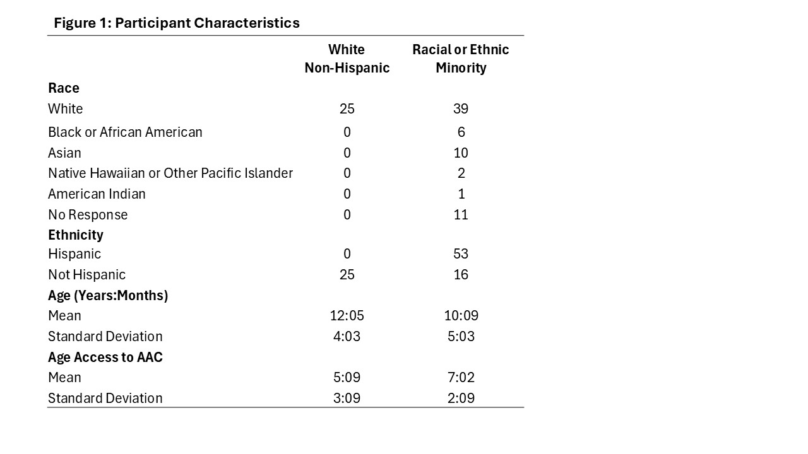
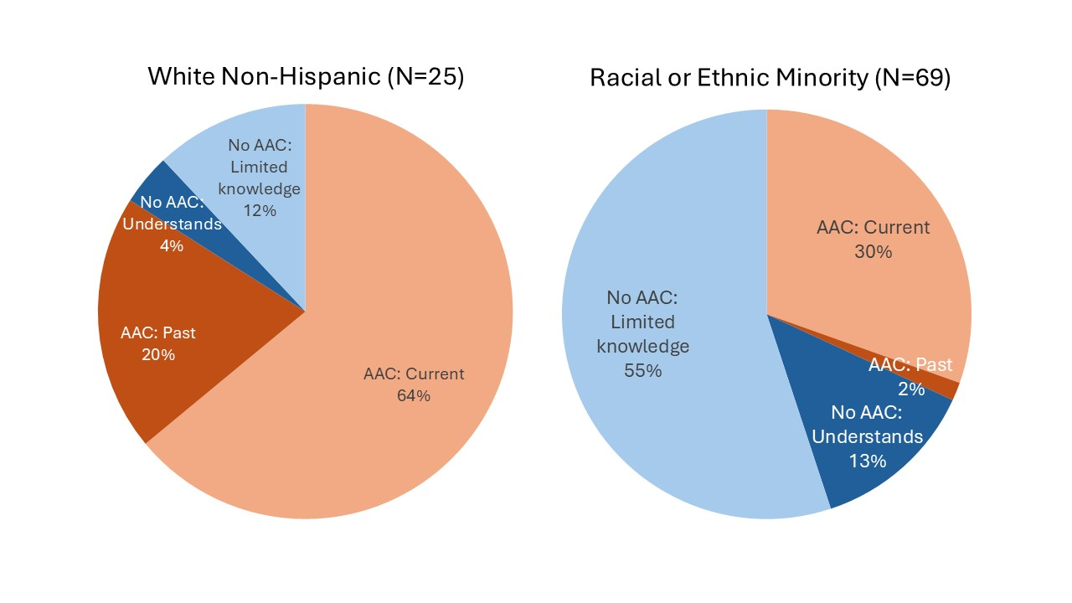
Figure 2: Rates of AAC Access and Knowledge by Racial and Ethnic Group

