Title: Quantifying autistic traits in Down syndrome: an initial investigation of effects of cognitive differences and comparison with a sample at higher familial likelihood for ASD
Authors: Carolyn Lasch¹, Annette M. Estes², Chimei M. Lee³, Jed T. Elison³, Jason J. Wolff³, Dea Garic⁶, Rebecca L. Grzadzinki⁶, Stephen R. Dager², Juhi Pandey⁴, Robert T. Schultz⁴, Lonnie Zwaigenbaum⁵, Heather C. Hazlett⁶, Kelly N. Botteron¹, Joseph Piven*⁶, John R. Pruett, Jr.*¹, & Natasha Marrus*¹ for the IBIS Network
* co-senior authors
Introduction: Down syndrome (DS) is the most common genetic condition associated with intellectual disability. It also presents with increased likelihood of autism spectrum disorder (ASD) diagnosis and subthreshold ASD-related behaviors (e.g., differences in attention and aspects of social cognition implicating executive function [e.g., Chanell, 2020]). However, the possible impact of DS-related cognitive differences on the interpretability of ASD trait measures has not been examined across different developmental periods. Here, we examine quantitative autistic traits (QATs) in children with DS in two developmental periods: school-age (SA), using the clinically validated Social Responsiveness Scale-2 (SRS-2, Constantino & Todd, 2003) and early childhood (EC), using the Video-Referenced Rating of Reciprocal Social Behavior (vrRSB; Marrus et al., 2015), a downward extension of the SRS-2 that has been validated in early childhood (EC) community samples. The objectives of our study were: 1) Compare vrRSB and SRS-2 scores in children with DS to groups of children at low and high familial likelihood (LL/HL) for ASD, including HL children with and without an ASD diagnosis. 2) Evaluate the performance of these QAT metrics in participants with DS when controlling for developmental/cognitive level. HL-noASD children serve as reference group to better compare effect of ‘elevated ASD likelihood’ between DS and HL-noASD groups.
Methods: Participants were recruited via the Infant Brain Imaging Study (IBIS). This multisite, longitudinal study includes infant siblings at high and low familial likelihood for ASD (HL by virtue of an older sibling with ASD), as well as samples of infants and SA children with DS. ASD diagnoses were based on clinical best estimates, including ADOS and ADI-R at 24m (EC visit) or SA visit (6-14 years). The EC sub-sample included 33 HL-noASD (19 F), 28 HL-ASD (11 F), and 23 LL-noASD (9 F) toddlers and 23 (15 F) with DS and noASD. The SA sample included 18 DS-noASD (11F), 106 HL-noASD (47F), 45 HL-ASD (13F) and 76 LL-noASD (31F). Children with comorbid DS and ASD (2 at EC, 3 at SA) were excluded to prevent over-fitting models. In EC, participants completed the Bayley Scales of Infant and Toddler Development, 4th edition (Bayley), and parents completed the vrRSB at 24.9 months (SD=0.96). At SA, participants completed the Differential Ability Scales (DAS) at 5-14 years old (M=9.8, SD=1.8), and parents completed the SRS-2. Separate EC and SA regressions examined how DS predicted QATs in comparison to reference group of HL-noASD participants, and how inclusion of developmental/cognitive level alters the effect of DS on QATs. Chronological age was included as a control variable in EC models based on previously observed developmental change in QATs during EC.
Results: In the EC sample, Bayley scores were significantly lower in infants with DS (M=65.7) than all other participants (M=100.1), t(57) =11.14, B=2.02, p<.001. vrRSB scores of participants with DS were not differentiable from HL-noASD infants (p=.33; Model 1a). However, after adding Bayley Cognitive scores to the model (Model 1b), DS diagnosis was associated with lower vrRSB scores (lower QATs) compared to HL-noASD participants (B=-0.39, p<.001).
In the SA sample, DAS General Cognitive Ability (GCA) standard scores were significantly lower in children with DS (M=53.4) vs. all other participants (M=108.9), t(32) =26.9, B=3.21, p<.001. Participants with DS had significantly higher SRS-2 scores (higher QATs) than HL-noASD children (B=0.253, p<.001; Model 2a). However, after adding DAS GCA scores to the model (Model 2b), SRS-2 scores of children with DS were not differentiable from HL-noASD children (p=.36). See Table for full comparisons of models in both samples, and Figure for associations between cognitive level and QAT scores in each subsample.
Discussion: In both EC and SA samples, inclusion of developmental/cognitive level in predictive models alters interpretation of group differences in QATs for samples with varying cognitive abilities and ASD likelihood. Unlike in LL and HL participants, at both EC and SA, interpretation of QATs in children with DS varies when accounting for cognitive level. For the DS group, this effect is especially pronounced in early development (EC), when QAT traits and overall cognitive profiles are still consolidating in all sub-samples. When measuring QATs in children with DS or other conditions associated with intellectual disability, accounting for developmental appropriateness of a screening tool such as vrRSB or SRS-2 may be prudent.
References:
- Channell, M.M. (2020). The Social Responsiveness Scales (SRS-2) in school-age children with Down syndrome at low risk for autism spectrum disorder. Autism and developmental language impairments, 5(1-12).
- Constantino, J. N., & Todd, R. D. (2003). Autistic traits in the general population: A twin study. Archives of General Psychiatry, 60(5), 524–530.
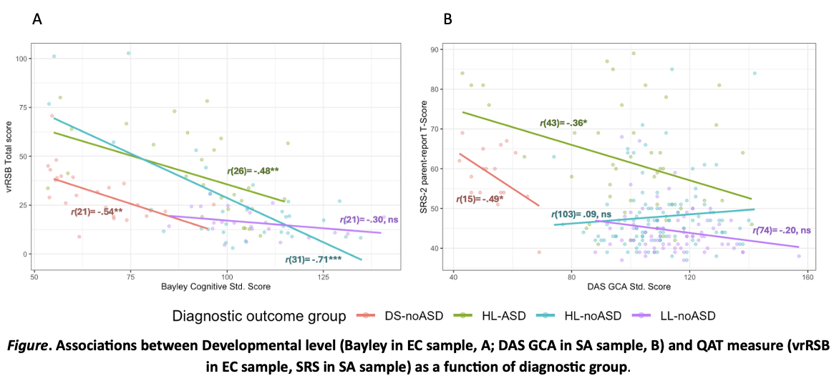
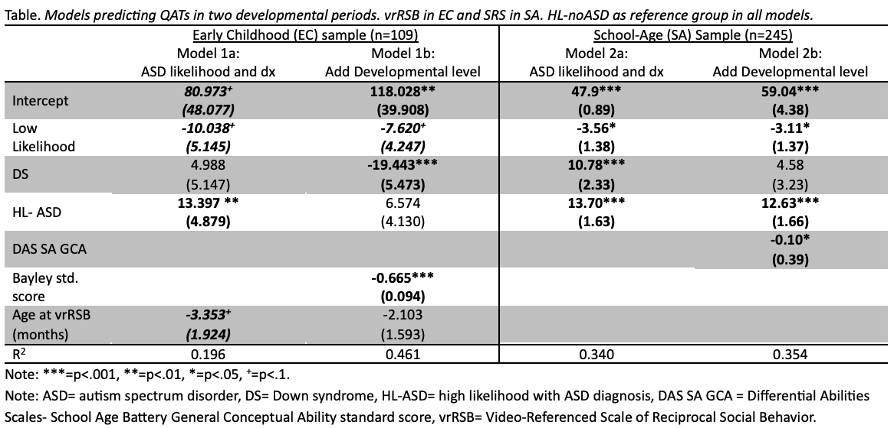
- Marrus, N., Glowinski, A. L., Jacob, T., Klin, A., Jones, W., Drain, C. E., Holzhauer, K. E., Hariprasad, V., Fitzgerald, R. T., Mortenson, E. L., Sant, S. M., Cole, L., Siegel, S. A., Zhang, Y., Agrawal, A., Heath, A. C., & Constantino, J. N. (2015). Rapid video-referenced ratings of reciprocal social behavior in toddlers: a twin study. J Child Psychol Psychiatry, 56(12), 1338–1346.

Washington University in St. Louis
2 University of Washington
3 University of Minnesota, Twin Cities
⁴ Children’s Hospital of Philadelphia
⁵ University of Alberta
⁶ University of North Carolina, Chapel Hill

