**Title**: Executive function profiles in preschoolers with Down syndrome: comparing children with and without elevated autism features

**Authors**: Chandler Knott¹˒², M.A., Kali Kecskemeti¹, B.S., and Elizabeth Will¹, Ph.D.

**Introduction**: Co-occurring autism spectrum disorder (ASD) affects an estimated 15 – 17% of individuals with Down syndrome (DS; Mai, 2019; Parker, 2010; Presson, 2013). The nearly universal intellectual disability and associated developmental delays characteristic to DS (Grieco et al., 2015) can complicate assessment of ASD in DS, especially during early childhood (Thurm et al., 2019). While existing research has explored some features differentiating ASD within DS, most of this work has focused on ASD-specific screeners and diagnostic tools (DiGuisseppi et al., 2010; Godfrey 2019; Lee et al., 2015), with little investigation into non-ASD-specific phenotypic features that may distinguish co-occurring ASD within DS. Furthermore, potential factors contributing to *misclassification* of ASD within DS remain unknown. Executive dysfunction is a prominent feature of the DS cognitive-developmental phenotype, evidenced by difficulties in working memory (Daunhauer et al., 2014; Daunhauer et al., 2017; Lanfranchi et al., 2009), inhibitory control (Daunhauer et al., 2017; Lee et al., 2015; Lanfranchi et al., 2010;), and planning (Daunhauer et al., 2014). Although executive dysfunction has also been implicated in ASD (Demetriou et al., 2018), its role in the manifestation of ASD features in DS has not been explored. We aimed to address this gap by examining profiles of executive function (EF) and potential profile differences between preschoolers with DS with and without elevated features of ASD. Increased understanding of the relationship between EF difficulties and ASD symptomatology in young children with DS may have important implications for the assessment and differential diagnosis of ASD in this population.

**Method**: Participants included 26 preschool children with DS between the ages of 35 and 63 months of age (*M* CA = 47.35). Participants were allocated into separate groups based on clinical cutoff scores derived from the Autism Diagnostic Observation Schedule, Second Edition (ADOS-2). A total of 11 participants (*M* CA = 46.17) exceeded clinical cutoffs for autism spectrum and 15 participants’ (*M* CA = 48.21) scores fell into the non-spectrum range on the ADOS-2. Participants’ parents completed the Behavior Rating Inventory of Executive Function Preschool Version (BRIEF-P; Gioia et al., 2003) as a measure of executive functioning in everyday contexts across three overall indices: Inhibitory Self-Control, Flexibility, and Emergent Metacognition, and five subdomains: Inhibit, Shift, Emotional Control, Working Memory, Plan/Organize. Higher scores indicate greater impairment, with T-scores at or above 65 representing clinically elevated levels of executive dysfunction. Standardized T-scores from the three overall indices and five subdomains were used in analyses. Specifically, two separate multivariate analysis of variance (MANOVA) models were estimated, with the first comparing index profiles across groups and the second comparing subdomain profiles across groups.

**Results**: Patterns on the BRIEF-P profile indicated that both groups were clinically elevated on the Working Memory subdomain and the Emergent Metacognition index, but did not score in the clinical range on any other subdomain or index. Results revealed no significant differences between groups across broad BRIEF-P indices (Pillai's Trace = .074, *F*(3, 22) = 0.58, *p* = .63, partial η2 = .074). However, results from the model comparing BRIEF-P subdomain profiles revealed significant group differences on the Shift domain, where the group exceeding ADOS-2 cutoffs showed significantly worse shifting abilities (*F*(1, 24) = 4.94, *p* = .036, partial η2 = .171). Groups were not significantly different on the Inhibit (*F*(1, 24) = .342, *p* = .56), Emotional Control (*F*(1, 24) = .427, *p* = .519), Working Memory (*F*(1, 24) = .189, *p* = .668), or Plan/Organize (*F*(1, 24) = .027, *p* = .872) subdomains. Results from both MANOVA models are depicted in Figure 1.

**Discussion:** Findings suggest that children with DS with and without elevated features of autism demonstrate generally similar levels of parent-reported executive dysfunction across most EF subdomains, except for in shifting abilities. Consistent with previous research indicating prominent working memory deficits in DS (Daunhauer, 2014; Lee et al., 2015), the Working Memory and Plan/Organize subscales of the BRIEF-P emerged as primary areas of EF impairment across both ADOS-2 classification groups. Notably, the identified group difference in the Shift subscale indicates that children with DS who exceed cutoffs for ASD on the ADOS-2 experience more difficulties with transitions, tolerating change, and switching attention compared to those falling in the non-spectrum range. This aligns with existing literature suggesting that children with non-syndromic autism often exhibit significantly impaired cognitive flexibility and attentional shifting (Corbet et al., 2009; Sanders et al., 2008). These findings may help elucidate why some children with DS exceed ADOS-2 cutoffs without meeting full diagnostic criteria for ASD. While further research is necessary to explore the associations between shifting, other EFs, and elevated autism features in preschoolers with DS, the present study findings highlight potential implications for the differential assessment of ASD in this population.

**Figure 1**

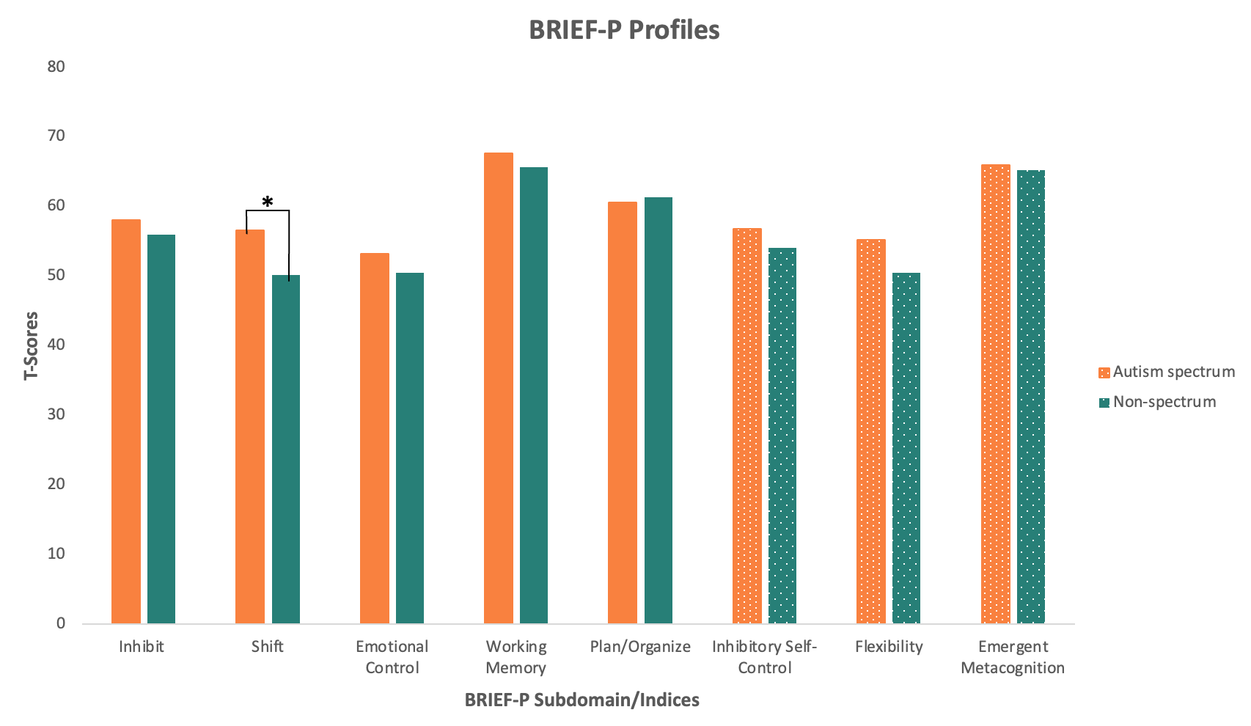

**References:**

Corbett, B., Constantine L., Hendren, R.,Rocke, D., Ozonoff, S. Examining executive functioning in children with autism spectrum disorder, attention deficit hyperactivity disorder and typical development. *Psychiatry Research*, Volume 166, Issues 2–3, Pages 210-222, ISSN 0165-1781, <https://doi.org/10.1016/j.psychres.2008.02.005>.

Daunhauer L.A., Fidler D.J., Hahn L., Will E., Lee N.R., Hepburn S. (2014) Profiles of everyday executive functioning in young children with down syndrome. *Am J Intellect Dev Disabil.* doi: 10.1352/1944-7558-119.4.303. PMID: 25007296; PMCID: PMC4512669.

Daunhauer L.A., Gerlach-McDonald B., Will E., Fidler D.J. (2017) Performance and Ratings Based Measures of Executive Function in School-Aged Children with Down Syndrome. *Dev Neuropsychol*. doi: 10.1080/87565641.2017.1360303. PMID: 28985480.

Demetriou, E. A., Lampit, A., Quintana, D. S., Naismith, S. L., Song, Y. J., Pye, J. E., ... & Guastella, A. J. (2018). Autism spectrum disorders: a meta-analysis of executive function. *Molecular psychiatry*, *23*(5), 1198-1204.

DiGuiseppi, C., Hepburn, S., Davis, J. M., Fidler, D. J., Hartway, S., Lee, N. R., ... & Robinson, C. (2010). Screening for autism spectrum disorders in children with Down syndrome: population prevalence and screening test characteristics. *Journal of Developmental & Behavioral Pediatrics*, *31*(3), 181-191.

Gioia, G. A., Espy, K. A., & Isquith, P. K. (2003). Behavior Rating Inventory of Executive Function–Preschool Version (BRIEF-P). *Psychological Corporation.*

Godfrey, M., Hepburn, S., Fidler, D. J., Tapera, T., Zhang, F., Rosenberg, C. R., & Lee, N. R. (2019). Autism spectrum disorder (ASD) symptom profiles of children with comorbid Down syndrome (DS) and ASD: A comparison with children with DS-only and ASD-only. *Research in Developmental Disabilities*, *89*, 83-93.

Grieco, J., Pulsifer, M., Seligsohn, K., Skotko, B., & Schwartz, A. (2015, June). Down syndrome: Cognitive and behavioral functioning across the lifespan. In *American Journal of Medical Genetics Part C: Seminars in Medical Genetics* (Vol. 169, No. 2, pp. 135-149).

Lanfranchi, S., Jerman, O., & Vianello, R. (2009). Working memory and cognitive skills in individuals with Down syndrome. *Child*  *Neuropsychology*, *15*(4), 397-416.

Lanfranchi S.,Jerman O., Dal Pont E.,Alberti A. & Vianello R. (2010) Executive function in adolescents with Down Syndrome. *Journal of Intellectual Disability Research vol 54*. doi: 10.1111/j.1365-2788.2010.01262.x

Lee N.R., Anand P., Will E., Adeyemi E.I., Clasen L.S., Blumenthal J.D., Giedd J.N., Daunhauer L.A., Fidler D.J., Edgin J.O. (2015) Everyday executive functions in Down syndrome from early childhood to young adulthood: evidence for both unique and shared characteristics compared to youth with sex chromosome trisomy (XXX and XXY). *Front Behav Neurosci*. doi: 10.3389/fnbeh.2015.00264. PMID: 26539087; PMCID: PMC4611056.

Mai CT C.T., Isenburg J.L., Canfield M.A., Meyer R.E., Correa A., Alverson C.J., et al., (2019) National population-based estimates for major birth defects, *Birth Defects Res*.

Parker S. E., Mai C. T., Canfield M. A., Rickard R., Wang Y., Meyer R. E., et al. (2010). Updated national birth prevalence estimates for selected birth defects in the United States, 2004–2006. *Birth Defects Res. Part A Clin. Mol. Teratol.*

Presson A.P., Partyka G., Jensen K.M., Devine O.J., Rasmussen S.A., McCabe L.L., et al. (2013) Current estimate of down syndrome population prevalence in the United States. *J Pediatr* doi: 10.1016/j.jpeds.2013.06.013

Sanders, J., Johnson, K., Garavan, H., Gill, M., Gallagher, L. (2008) A review of neuropsychological and neuroimaging research in autistic spectrum disorders: Attention, inhibition and cognitive flexibility. *Research in Autism Spectrum Disorders*, Volume 2, Issue 1, Pages 1-16, ISSN 1750-9467, https://doi.org/10.1016/j.rasd.2007.03.005.

Thurm, A., Farmer, C., Salzman, E., Lord, C., & Bishop, S. (2019). State of the field: Differentiating intellectual disability from autism spectrum disorder. *Frontiers in psychiatry*, *10*, 526.

University of South Carolina

2 University of North Carolina Chapel Hill