Title: Modeling the latent factor structure of the “EXcEEDS” (EXecutive function Early Evaluation in Down Syndrome) Battery
Authors: Van Deusen, K.,¹ Prince, M.A.,^{1,2} Walsh, M.M.,¹ Patel, L.R.,³ Esbensen, A.J.,^{4,5} Thurman, A.J.,⁶ Pinks, M.E., ¹ Abbeduto, L.,⁶ Oser, C., ¹ Daunhauer, L.A.,¹ and Fidler, D.J.¹
Introduction: Executive function (EF) encompasses the cognitive regulatory processes used to organize goal-directed behavior,¹ and includes working memory, inhibition, and cognitive flexibility.² EF is an important predictor of health, occupational engagement, and academic achievement for individuals with and without disabilities.^{3–5} Down syndrome (DS) is associated with EF vulnerabilities throughout the lifespan, and EF is associated with daily living skills, academic achievement, and employment in this population.^{6–8} Interventions that promote EF in children with DS would be beneficial, however, validated outcome measures are needed to capture potential treatment effects.⁹ Childhood EF is often assessed through laboratory-based games and activities that involve aspects of development unrelated to EF, like language and motor skills. As a result, currently available assessments involve measurement error when administered to individuals with DS, who tend to show challenges in these areas. Validated EF measurement tools are needed to advance treatment science in this area for children with DS.
The “EXcEEDS” (EXecutive function Early Evaluation in Down Syndrome) Battery has been developed to minimize the impact of confounding developmental domains when assessing EF in young children (2 to 8 years old) with DS. The battery is made up of adapted tasks that evaluate short-term memory (STM), working memory (WM), inhibition (Inhib), and cognitive flexibility (CF). Each of the games are presented with no expressive language requirements and reduced receptive language and motor requirements. Tasks also include teaching trials to support comprehension and are designed to motivate participants to maintain engagement. This study aimed to validate the “EXcEEDS” Battery by modeling its latent factor structure to determine whether it aligned with prevailing theoretical factor structure of EF when administered to a sample of children with DS.
Method: Participants included 124 children with DS (chronological age = 2.47 to 8.71 years, Mean (M) = 5.26, Standard Deviation (SD) = 1.59). Measures included an assessment of overall developmental status and the EXcEEDS Battery tasks. Children’s mental ages ranged from 0.42 years to 6.33 years (M = 2.37; SD = 0.91). The EXcEEDS Battery consists of eight tasks that examine STM (1), WM (1), Inhib (3), and CF (3). The WM, STM, and CF tasks were scored in-vivo by an examiner, and video recordings of the Inhib tasks were scored through software-based behavior coding with trained research assistants naïve to study hypotheses (inter-rater reliability = .85,.95, and .97 respectively). Exploratory graph analysis (EGA) was used to visualize the latent factor structure of the EXcEEDS Battery tasks.
Results: The EGA identified a 2-factor solution for the eight tasks. The factors were positively correlated and clearly distinguishable. One factor was defined by the three Inhib tasks, so was named “inhibitory control” and the second factor was defined by WM, STM, and CF tasks, which was named “working memory/flexibility” (Figure 1).
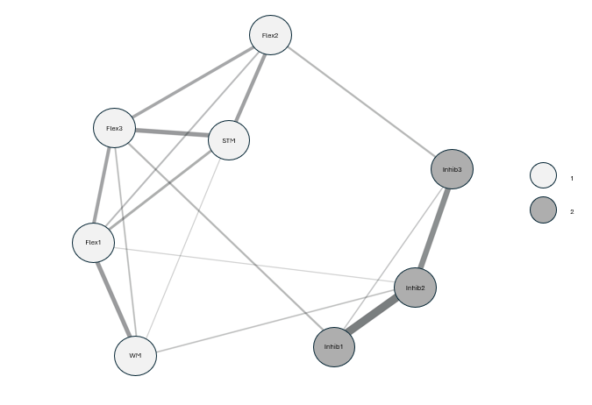
Figure 1. Exploratory Graph Analysis
Discussion: The primary aim of this study was to evaluate a battery of adapted childhood EF tasks designed to reduce developmental confounds, such as expressive language, and reduce receptive language and motor requirements. EGA resulted in two meaningfully interpretable factors. The inhibition measures loaded together onto one factor and the cognitive flexibility measures loaded onto a second factor along with working and short term memory tasks. Notably, the cognitive flexibility and inhibition tasks loaded onto separate factors, without cross-loading by task type. In conjunction with previous reports to validate specific measures used in the EXcEEDS Battery,^{8,10–12} this EGA provides further evidence of the utility of these developmentally sensitive and scalable measures by demonstrating construct validity in the assessment of specific EF component processes. Although the working memory and short term memory tasks loaded onto a factor together with cognitive flexibility, it may be the case that these dimensions are more unitary than dissociable in young children with DS. Previous work examining the structure of EF in early childhood has reported mixed findings regarding the dissociability of the three subdomains of EF during early childhood,¹³ which may also be the case in children with DS. This work advances the current efforts to validate outcome measures for future DS treatment trials.⁹
References:
1. Müller U, Kerns K. The development of executive function. In: Liben LS, ed. Handbook of Child Psychology and Developmental Science: Cognitive Processes, Vol. Vol 2. John Wiley & Sons, Inc., xxv; 2015:571-623.
2. Miyake A, Friedman NP, Emerson MJ, Witzki AH, Howerter A, Wager TD. The unity and diversity of executive functions and their contributions to complex “frontal lobe” tasks: A latent variable analysis. Cogn Psychol. 2000;41(1):49-100.
3. Moffitt TE, Arseneault L, Belsky D, et al. A gradient of childhood self-control predicts health, wealth, and public safety. Proc Natl Acad Sci U S A. 2011;108(7):2693-2698.
4. Barkley RA, Murphy KR. Impairment in occupational functioning and adult ADHD: The predictive utility of executive function (EF) ratings versus EF tests. Arch Clin Neuropsychol. 2010;25(3):157-173.
5. Best JR, Miller PH. A developmental perspective on executive function. Child Dev. 2010;81(6):1641-1660.
6. Will EA, Fidler DJ, Daunhauer LA, Gerlach-McDonald B. Executive function and academic achievement in primary - grade students with Down syndrome. J Intellect Disabil Res. 2017;61(2):181-195.
7. Tomaszewski B, Fidler DJ, Talapatra D, Riley K. Adaptive behaviour, executive function and employment in adults with Down syndrome. J Intellect Disabil Res. 2018;62(1):41-52.
8. Van Deusen K, Prince MA, Walsh MM, et al. Laboratory-based measures of executive function and daily living skills in young children with Down syndrome: informing future interventions. J Intellect Disabil Res. Published online August 7, 2024. doi:10.1111/jir.13176
9. Esbensen AJ, Hooper SR, Fidler D, et al. Outcome measures for clinical trials in Down syndrome. Am J Intellect Dev Disabil. 2017;122(3):247-281.
10. Walsh MM, Van Deusen K, Prince MA, et al. Preliminary psychometric properties of an inhibition task in young children with Down syndrome. J Intellect Disabil. Published online December 8, 2023:17446295231218776.
11. Pinks ME, Van Deusen K, Prince MA, et al. Psychometric evaluation of a working memory assessment measure in young children with Down syndrome. Res Dev Disabil. 2023;139:104564.
12. Van Deusen K, Prince MA, Thurman AJ, et al. Evaluating an adapted reverse categorization task to assess cognitive flexibility in young children with Down syndrome. J Intellect Disabil Res. Published online 2023. doi:10.1111/jir.13040
13. Wiebe SA, Espy KA, Charak D. Using confirmatory factor analysis to understand executive control in preschool children: I. Latent structure. Dev Psychol. 2008;44(2):575-587.

Colorado State University
² University of Southern California
³ University of Colorado Anschutz Medical Campus
⁴ Cincinnati Children’s Hospital and Medical Center
⁵ University of Cincinnati
⁶ University of California Davis Health

